A 2020 SIMPLIFIED A’LEVEL PHYSICS PRACTICAL GUIDE

TABLE OF CONTENTS

PART I
INTRODUCTION
- Aims of physics a practical……………………………………………………3
- How to prepare for a practical …………………………………………………3
PART II
MEASUREMENT OF QUANTITIES…………………………………………….3
RECORDING MEASUREMENTS……………………………………….………16
DATA MANIPULATION……………………………………………….…………17
PART III

PRESENTATION OF PRACTICAL WORK………………...…………………20
TREATMENT OF ERRORS……………………………………………………...33
PART IV
PRACTICAL QUESTIONS ……………………………………………………...36
APPARATUS FOR EACH EXPERIMENT……………………………………..125

PART 1
INTRODUCTION
Aims for a physics practical
- To determine constants
- To verify the fundamental laws and principals covered in the theoretical part.
- To get familiar with use of instruments
- To be creative in problem solving
How to get prepared for performing an experiment
- Read the instructions carefully
- Identify the apparatus to be used present on the table (from the procedures and structure if any)
- Identify the measurements to be made.
- Identify the quantities to be entered in the table of result
- Setup the apparatus as I the structure/diagram or as instructed from the procedures.

MEASUREMENT OF QUANTITIES
Measurement refers to the process of finding the size, quantity or degree of an object. This can be done by the help of measuring instruments. We can measure physical quantities like length, mass, time, temperature and others.
Measuring instruments are instruments that show the magnitude of something.
Length (distance between two points).
In physics practical we measure short distances like breadth of a ruler or glass block, diameter of an object like a wire and length between two points on a meter ruler. Usually in meters, centimeters and millimeters. Short length can be measured using a meter ruler, Verniercaliper micrometer screw gauge and an engineering caliper by engineers.
Meter Ruler
It measures to one 1mm. Usually in laboratory we use one meter rule and half meter rule.
One should note that 100cm = 1m and 1cm = 10mm.
It is used to measure short distance in straight line between two points (length).
How to take readings from ruler
- Place the edge of the rule along the straight line covering the length to be measured with a starting mark or point.
- When taking readings from the rule the eye must always be placed vertically above the mark to be read. This is to avoid errors due to parallax.
Figure 1 shows a correct position to take a reading on a rule.
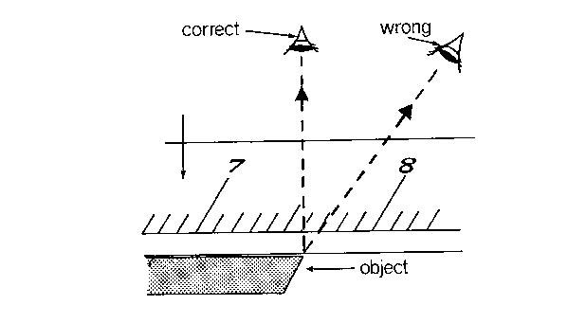

Verniercaliper
A Verniercaliper is to measure the internal and external diameter for example for a tube, beakers, cylinders e.t.c .
It has two scales, the main scale in centimeters and millimeters and the Vernier scale (short scale) which slide along.
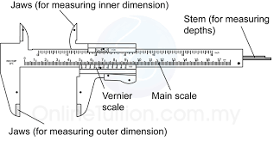
How to use a Verniercaliper to measure
- Place the object whose diameter to be measured between the jaws. The outer side jaw measures the outer diameter and the inside jaws measures the inner diameter.
- Slide the movable jaw until the jaws just touch the sides of the object without applying excessive pressure.
- Take the readings from the scale.
How to take readings from the scale

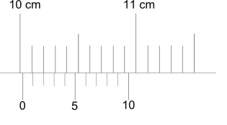
- Look at the zero mark on the Vernier scale, look for the mark on the main scale which is just before the zero mark on the Vernier scale. This gives the approximate reading. In figure 2 the reading is 10.00cm
- Look for the point on the Vernier scale where one of it’s mark matches exactly with one on the main scale and take readings. In figure 2 this is 0.02cm (one division on the Vernier = 0.01cm, from our scale the mark is and therefore multiplied by 0.01 since their two divisions)
- Add the readings on the Vernier scale and that of the main scale.
- Measurement = 10.02cm.

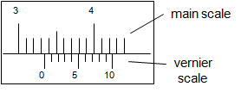
Main scale reading = 3.30cm
Vernier scale reading = 4x0.01
=0.04cm
Measurement reading is 3.30cm plus 0.04cm = 3.34cm
Micrometer screw gauge
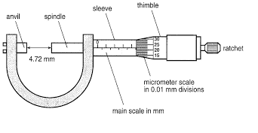
It is to measure diameter of apiece of wire, spokes, thickness of a paper or rule and a like.
A micrometer screw gauge has two scales, the main scale (sleeve scale) on the shaft (sleeve) and the fractional scale on the rotating barrel.
The main scale is graduated in millimeters along the upper scale and half millimeter along the lower scale.
The fractional scale on the thimble has 50 divisions or 100 divisions and one complete turn represents 0.5mm for the one with 50 divisions and 1.0mm for one with 100 divisions.
For both cases 1 division = 0.01mm on fractional scale.
The spindle moves through a fixed distance during each complete turn because of a uniform pitch. If the pitch is 0.5mm it’s the distance turned by the spindle in one complete turn.

How to use a micrometer screw gauge to measure
- Place the object to be measured between the anvil and the spindle.
- Carefully turn the barrel until the spindle holds the object.
- Turn the frictional clutch to obtain to obtain the right pressure just at the instant when the rachet makes the first click of sound.
- Take the readings.
Examples 1
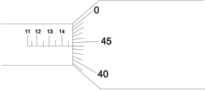

How to take the readings from the scale
- Read a mark on the main scale (sleeve scale) before the thimble or fractional scale. In figure 3 this is 14.50mm.
- Read the addition fraction of a millimeter from the fractional scale and is a mark that is in line with the main scale on the shaft. In figure 3 this is 0.44mm (44 divided by 100 ).
- Add the readings on both scales.
Measurement = ( 14.50 + 0.44)mm = 14.94mm
The object in the has a length of 14.94mm.
Example2

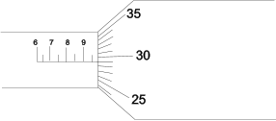
Main scale reading = 9.50mm
Fraction scale reading = 0.29mm
Measurement = (9.50 + 0.29)mm = 9.79mm

Mass
Mass is the quantity of matter contained by a body. Mass can be measured in milligrams
(mg), grams (g), kilograms (kg) and metric tonnes (ton).
1gram (g) = 1000milligrams (mg)
1 kilogram (kg) = 1000grams (g)
1metric tonne (ton) = 1000kilograms (kg)
In most cases mass in the laboratory can be measured using a triple beam balance, spring balance, electronic beam balance e.t.c
How to use a Triple beam balance
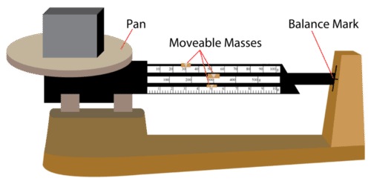
- Place the object to be measured on the pan at the left side of the balance.
- Slide the movable masses to the right until the right end arm is at level with the balance mark. This is done by moving the larger masses first, and then fine tune the measurement by moving the smaller masses as needed.
- Read the three scales to determine values of the masses that were moved to the right. Their combined mass is equal to the mass of the object.
The figure below is an enlarged version of the scale of the triple beam balance. It allows you to read the scales.
The middle scale which measures the largest movable mass, reads 300grams.
This is followed by the top scale which reads 30grams and lastly bottom scale which reads 5.1grams.
Therefore the mass of the object in the pan is 335.1grams (300grams + 30grams + 5.1grams).
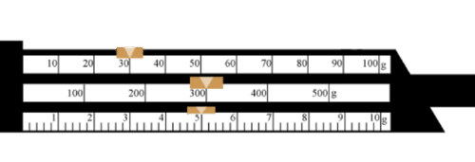
NOTE: The maximum mass a triple beam balance can measure is 610grams that is to say (500 + 100 + 10) grams and the smallest mass it can measure is 0.1gams.
The electronic balance
To measure very small masses an electronic balance is used.
This electronic balance makes easier to accurate measurement because mass is shown as a digital readout.
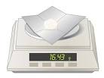
In the figure above, the electronic balance is being used to measure mass of white powder placed on a plastic weighing tray.
The mass of the tray is a lone is measured first (say it is m₀) and then subtracted from the combined mass of the tray and powder , (16.43 - m₀) grams and this is equal to the mass of the powder.
Spring Balance
Spring balance measures weight but can be calibrated for accurate measurement of mass.
It may be labeled in both units of weight and mass.
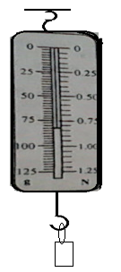
In the diagram 25g = 10 small divisions
1 small division = 25g divide by10 = 2.5g.
From the diagram the reading is 75 + (3x2.5) = 82.5g.
The reading is taken to one decimal place.
Compression balance
It works on the principle that the greater the weight pressing the pan the greater the compression. Hence it obeys Hooke’s law. It measures mass in grams or kilograms and sometimes are calibrated in newtons.
Measurement of volume
Measurement of the volume of liquids we use measuring cylinder, Beaker, a burette and pipette which are transparent and calibrated in volume units i.ecm³ .
The vertical height of the liquids is read off as the volume.
In taking readings, the surface of the liquid poured into a narrow container is not flat but slightly curved at the edge. This makes a meniscus of the liquid (concave).
The liquid level is always read from the center of the curved surface. In figure 4 the reading is 18.5cm³ (read from the bottom of the meniscus).
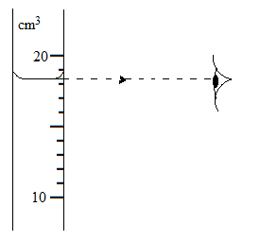
Electric current.
Electric current is measured in amperes (A). Ammeters is used to measure the electric current in the electricity practicals. The ammeters do measure current in amperes (A correct to two decimal places.
We do have two types viz. single range ammeters and double range ammeters. When connecting the ammeter to circuit we connect positive terminal of the meter to the positive terminal of the battery or cell while the negative terminal is connected to the negative terminal of the battery or cell. The positive terminal of the ammeter is normally coded with a red colour while the negative terminal is coded with a black color
- Single range ammeter
This type of ammeter has only two terminals. One is positive and coded with a red color and a word COM while the other is negative and is coded with a black color.
Below is a diagram showing the scale of this type of ammeter
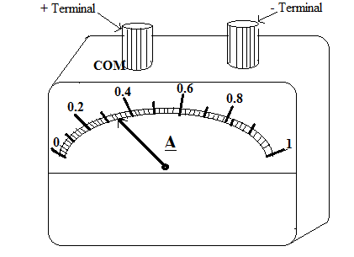
In the reading the ammeter we use the knowledge of proportionality. We have to first establish what the smallest division represents. For instance from 0 to 0.2A, there are ten(10) small divisions and they represent 0.2A.
So 10 divisions =0.2A
- 1 small division =0.2/10=0.02A
The pointer is at point which is 7 divisions ahead of the reading of 0.2A.
So the reading =0.2+ (7x0.02)=0.3 4A
Note: The sale is linear even if it is curved. Linearity means that equal intervals on the scale represent equal changes in the current.
- Dual range ammeters

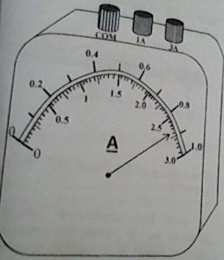

These types of ammeters have two ranges and have three terminals. Two of the terminals are coded black implying that they are the negative terminals. While the third one is labeled COM (implying common terminal i.e. it is the positive terminal.
Each of the two terminals that are coded black or red, in both cases they have their ranges current as the scales read written against them.
When using the ammeter we connect the common terminal to the positive terminal of the e.m.f source and one of the terminals with a label of current i.e. 1A or 3A, is connected to the negative terminal of the e.m.f source. We chose the scale to use depending on the magnitude of the current we are going to measure. e.g. You cannot use a scale of full scale deflection of 1A when measuring the current of 1.5A. ( we use the scale on which we have connected)
Note :
- In case you connect the meter in the circuit and you do not get a deflection you have to recheck on the connection to see if they are firm. If you are using switches that use plugs, then ensure that the plugs are not loose while in the sockets.
- If the meter moves in the wrong direction (anti clock wise direction) it means that the connections have been interchanged. So just swap the connections.
- Before using the meter ensure that it is at the zero mark. If it is not then appropriate adjustments must be made using the zero adjust screw.

In the diagram above if you consider the 3A scale range, ten(10) divisions represent 0.5A.
So using proportionality,
Division= 0.5/10=0.05A
Since the pointer is at a point that is four(4) divisions ahead of 2.5A reading then we have that,
Reading=2.5+ (4x0.05) =2.5+0.20=2.70A
Note: Do not write 2.7A but write 2.70A because the second decimal place is indicative of the degree of accuracy of the measuring instrument.
Regardless of the range of the scale that is on the ammeter you are using, you should always apply the knowledge of the proportionality to be able to read it.

The potential difference (p.d ) between two points in a circuit is measured using a voltmeter. The voltmeter is connected parallel to the device/conductor whose p.d is being measured. Just as the ammeters we connect positive of the meter to the positive e.m.f source and the negative terminal of the meter to the negative of the e.m.f source.
Hence the rule for connection is positive to positive and negative to negative. Since its scale is linear we still use the concept of proportionality to read it.
Measurement of angles
This done using a protractor. Angles are measured in degrees i.e. (0⁰ - 180⁰)
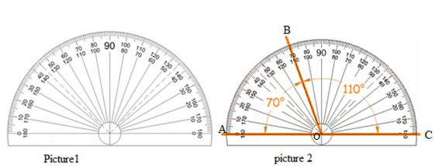
A protractor has the outer scale and the inside scale. The outer scale begins from zero to right and the inside from zero to the left. When using the protractor the line AC must lie along the reference line of the angle to be measured as in picture 2.
From picture 2 angle AOB is 70⁰ read from the outer scale and angle BOC is 110⁰ read from the inside scale, both angles add up to 180⁰.
Time.
Time is measured using a stop clock or a stock watch and its SI unit is seconds. One should note that 1minute = 60seconds and 1hr = 6ominutes.
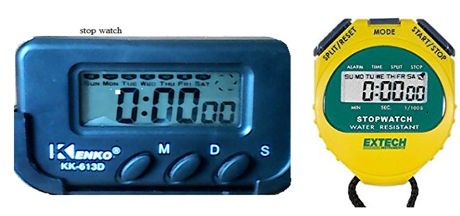
For the stop watch, M is pressed once into sport watch function mode and the beginning is shown as 0:00:00. D is pressed to start recording time and pressed aging to stop. After recording S is pressed to restart.
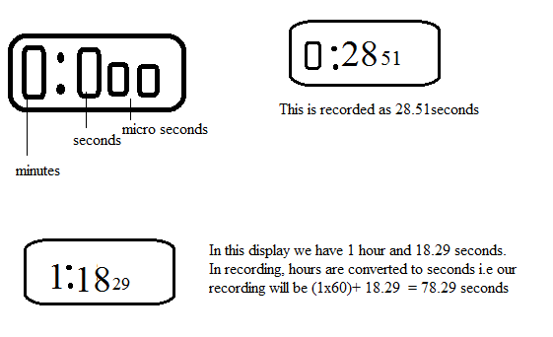s
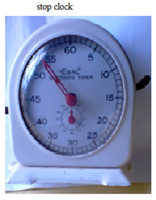
For a stop clock, moving the lever down starts the clock and moving it up stops the clock. Moving the reset lever resets the stop clock to zero.

We take readings to one decimal place and the last digit has to be a zero or a five e.g 20.0, 25.5, 44.0 e.t.c. Do not estimate the reading like 25.1, 30.2, 35.3, 20.6,30.7, 50.8 e.t.c.
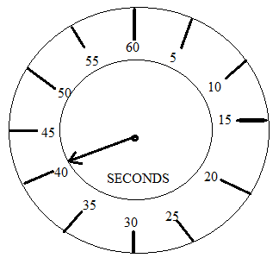
From the diagram above the reading is between 40 and 45, in such a case if the pointer is closer to 40 than 45 then we record 40.0s. And if it’s closer to 45 we record 45.0s. However if it’s in between the two we record 40.5s.
Temperature
Temperatureis measured in degrees and Kelvin. In ordinary laboratory we use a liquid in glass thermometer with a scale graduated in degrees celicious. It operates by recording the thermal expansion of the liquid in the glass.
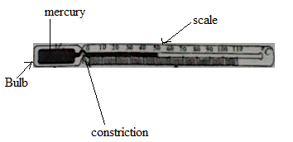
When using it, place in contact with the body whose temperature is to be measured and wait (for about 30seconds) until when the liquid (mercury, alcohol) column is stable or stopped rising. Take a reading of the graduated mark that coincides with the length of the liquid column. We record to one decimal place and the last digit must be a zero or 5.
RECORDING MEASUREMENTS
There are two types of measurement i.e. single and repeated measurements.
Single measurements
These are measurements taken on quantities like diameter of a wire, width/breadth of a glass block/ruler, thickness of a paper etc. Single measurements should be measured three times and entered in a small table. The average of the recorded values should be calculated outside the small table. Show the working when calculating the average.
Example
If you are required to measure and record the diameter of a wire.
Take measurement in three places (at the extreme ends and in the middle) and record in a small table as shown.
d₁ (mm) | d₂(mm) | d₃(mm)
2.67 | 2.68 | 2.68

The required diameter will then be the average of the three recorded values.
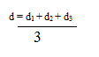
d= 2.68cm

REPEATED MEASUREMENTS (EXPERIMENTAL RESULTS)
Repeated readings are readings that are noted twice in the procedures. These readings usually are taken on variable quantities like extension, angle of refraction, current, voltage etc.
Such readings must be in the main table of results.
DATA MANIPULATION
(a) Number of decimal places
During addition and subtraction of quantities
In calculations involving addition and subtraction of quantities, decimal places are counted.
If two or more variables are added or subtracted, the number of decimal places in the answer has to equal that of the term with least number of decimal places.
Examples:
When adding
- 2.026 + 4.64 = 6.67 ( to 2 decimal places)
- 1.782 + 6.7 = 8.5 (to 1 decimal place)
When subtracting
- 24.672 - 20.51 = 4.16 ( to two decimal places)
- 2.541 - 0.21 = 2.33 ( to two decimal places)
Note the following instruments with the number of least decimal places to be recorded to;
INSTRUMENT | MEASURE | LEAST NUMBER OF DECIMAL PLACES
Meter ruler | Length | 1 dp
Vernier caliper | Short length like diameters | 2dp
Micrometer screw gauge | Short length like thickness and diameters of objects | 2dp
Voltmeter | p.d and in volts (v) | 2dp
Ammeter | Current in amperes (A) | 2dp
Stop clock | Time in seconds | 1dp
Stop watch | Time in seconds | 2dp
Protractor | Angles in degrees | 0dp
Beam balance | Mass | 1dp
Burette, beaker, pipette, measuring cylinder and conical flasks | Volume of liquids in cubic units | 0dp
Thermometer |  | 0dp

SIGNIFICANT FIGURES
Any physics experiment involves a series of measurements and each of these measurements is up to a certain degree of accuracy. The number of significant f figures you quote in any measurement depends on the least count of the measuring device. In doing calculation work on measurements, you may have to perform such operations as addition, subtraction multiplication and division.
It is important to note that in calculations the number of significant figures of measured quantities can be or equal to that of term with least significant figures in calculations i.e when multiplying or dividing quantities, the number of significant figures of each term is counted. The number of significant figures in the answer has to equal to that of the term with least significant figures being multiplied or divided.
Digits 1, 2, 3, 4, 5, 6,7, 8 and 9 are significant figures

NOTE:
Zeroes
These are divided into reading trapped and trilling zeroes.
- Leading zeroes these are zeroes that proceed all non zero digits. They are not counted as significant figures e.g. the number 0.000004567 has four significant figures. The six zeroes are leading zeroes and are not significant figures but help to allocate the position of the decimal of the decimal points.
- Trapped zeroes: These are zeroes between non zero digits. They are counted as significant figures. E.g. the number 9.0005673 has 8 significant figures. The three zeroes are trapped zeroes and are significant figures.
- Trilling zeroes :
These are zeroes at the right end of the number. They are counted as significant figures if they are not as result of rounding of. A trilling zero which is obtained as a result of rounding off. (if it is before decimal point)is not a significant figure 567. 9876 is rounded off to two significant figure we get 560.it therefore follows the zero in the approximate value 230 is not a significant.Similarly, 47.9 is rounded off to one significant figure we get 40. The trilling zero in this approximate value is also not a significant.
If the trilling zero as a result of calculation. Is after dp it is significant e.g if 5.67989 is rounded of to 4dp we get 5.670. in this case , the trilling is significant.
Note: trilling zero represents the accuracy of significant. Trilling zeros in experimental/ measured values obtained using an instrument is significant. This is because measured values are experimental values are always recorded t o precise number of dp. Therefore have a precise number of significant figures. E.g. suppose one measure length (l) and obtain 66.0cm,69.0cm and 72.0 all the trilling zero in these values are significant .thus 66.0,69.0,72.0 all has 3sf.similary,if one measure angle I and obtain i=100,300,500.all the trilling zero in these angle are significant thus the angle 100,300,500,has 2 significant figures.
Examples.
- The number 40.0 experimental value has 3 significant figures
- The number 0.670500 has six significant figures. The two trilling zero in this case are significant because they are not obtained as a result of rounding off.
Other xamples:
- 24.45X 1.23 = 30.0735 The answer should be 30.1 (to 3 significant figures)
- 1.782 X 6.12 = 10.9 (to 3 significant figures)
- 0.5 X 2.54 = 12.7 (to 3 significant figures)
- 1 X 20.34 = 20.34 ( to 4 significant figures)
- 1.50/ 1.445 = 1.04 (to 3 significant figures)
- When a calculated value or measured value is multiplied or divided by a constant or a whole number, the number of significant figures of the calculated value or measured value has to be used.
- One significant figure multiplied by a value with more than one significant figures, the answer should be to the significant figures of that value. ( check in (iii) and (iv) above ).

Examples
1. 2.
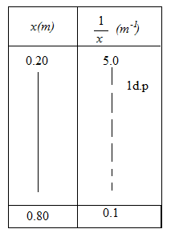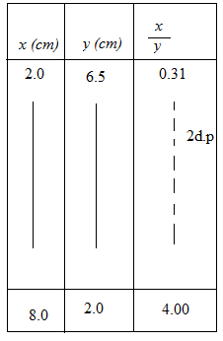

3.
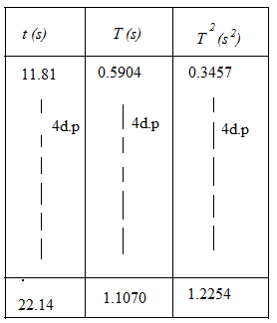

HOW TO ENTER DATA IN THE MAIN TABLE (TABLE OF RESULTS)
The main table of results must contain values of varying quantities. Constant values must be recorded outside the table.
The first row in the table contains symbols and units in curved brackets for the varying quantities.
Given values of a varying quantity. These are usually the given the procedures. They must be recorded the way they are given instructions unless when told to record otherwise. They should be recorded in the first column of the table.
Experimental values (measured values). These values are of varying quantity that is determined using instruments. They should be recorded to the accuracy of the instrument used i.e. to the correct decimal places and units.
Values of a derived quantity (calculated values). These values normally come from experimental values (measured values).
NOTE:
- At this level, calculated values entered in the table of results should be written to at least 2 decimal places to minimize errors for accuracy.
- Values of log, sine, tan and cosine should be in 3 decimal place.

PART III

5.0 FLOAT VALUES (CONSTANT AND NON MEASURED WHOLE NUMBERS)
A float value is a constant value like $π$ or is non-measured whole number whose significant figures and decimal places are infinite.
Non measured whole numbers e.g. 8,12,57,230,467etc.have an infinite number of significant figures e.g 8 can be also be written as 8.000000……..,also 467 as 467.0000…………….etc.
Constants like $e,π, etc.$also have infinite significant figures e.g. $e,π=2.7182818…and 3.1415926…respectively.$therefore constant and whole numbers are called float values because they have infinite number of significant figures and decimal places.
However if $e$ is rounded off to specific decimal places e.g.2.718 then $e$ is not a float value because of the specific decimal places i.e.4sf.
NB. A whole number obtained as a result of measurement, must have its specific number of significant figures and decimal places e.g.56⁰C is not a float because it has specifically 2sf and 0dp.
How to count significant figure when converting values of quantities from one unit to another?
When converting values of given quantities from one unit to another, we may the given values by a float or multiply t e number with a float. It’s important to note that in this case the number of sf remains the same e.g. 12.75g (4s.f) =$\left(\frac{12.72(4sf)}{1000(float)}\right)kg=0.01272kg 4sf=1.272X{10}^{-1}$kg (4sf)
5.1 calculating of reciprocal and trigonometric ratio
Generally with this case, 1 is a float i.e. reciprocals like $\frac{1}{u},\frac{1}{v},\frac{1}{V},\frac{1}{I},\frac{1}{R},\frac{1}{l} etc.$
In this case the answer should therefore be written to the same number of S.f as the value of the variable (denominator).e.g. if $v=45.6cm.then \frac{1}{v}=\frac{1 (float)}{45.6(3s.f)}=0.0219 (3sf)$
When manipulating data in table involving reciprocals the following should be put into consideration:
With this, the columns are majorly considered.
- Identify the largest value in the column of the quantity whose reciprocal is to be tabulated and count its significant figures.
- Calculate the reciprocal of value in the previous step above and write this processed value to the number of sf obtained above. Note its number of decimal places.
- Calculate the other values in the reciprocal column and write all the processed values to the same number of decimal places as obtained in the second step above
Examples:
Consider the table of results below.
$$l(cm)$$ | $$R(Ω)$$ | $$\frac{1}{l}\left({cm}^{-1}\right)$$ | $$\frac{1}{R}\left(Ω^{-1}\right)$$
55 | 7 | 0.0182 | 0.14
45 | 6 | 0.0222 | 0.17
35 | 5 | 0.0286 | 0.20
25 | 4 | 0.0400 | 0.25
15 | 3 | 0.0667 | 0.33
Table 1
From the table above, the values of $l$ were given to a specific number of decimal places i.e.0dp and therefore have specific sf. i.e. 2sf.thus they are not considered as float values.
In order to determine the number of decimal places for the obtained values of $\frac{1}{l}$and $\frac{1}{I}$ we use the largest value in$l andI respectively$.
The column of $\frac{1}{l}$
Using the largest value in column of $l$ ie.55 we have $\frac{1}{l}=\frac{1(float)}{{55}_{(3 sf but 4dp)}}.$since the processed value corresponding to the larger value in $l$ gives 4dp when written to3sf, the remaining values in the column of $\frac{1}{l}$should also be recorded to 4dp.
Note that the processed data in a given column must be to the same number of decimal places.
The column of $\frac{1}{I}:$
Considering the largest value in the column$I$, the value is 0.50 we have$\frac{1}{{0.5}_{1sf and 0dp}}$ =2.since the corresponding to the reciprocal of the largest value in $I$ gives 0 dp. If to 1sf, this follows that all values in the values in the column of $\frac{1}{I}$ are supposed to be written to 0 dp. If these values are written 1dp, it’s noted that there no sf variation as shown below.

$$R(Ω)$$ | $$\frac{1}{R}\left(Ω^{-1}\right)$$
7 | 0.1
6 | 0.2
5 | 0.2
4 | 0.3
3 | 0.3

$$R(Ω)$$ | $$\frac{1}{R}\left(Ω^{-1}\right)$$
7 | 0.14
6 | 0.17
5 | 0.20
4 | 0.25
3 | 0.33

Constant

Constant

Table2 Table3
The constant values in the column of $\frac{1}{R}$ in the table 2 above are as a result of over rounding off of the processed values. To eliminate constant values (to make these values more accurate), we increase the number of decimal places in this column by 1 as shown in table 3 above.
5.2 trigonometric ratios and logarithms
Values of sine, cosine, tangent and log must be recorded to three decimal places.
Examples
- The table below shows logarithms of some numbers
Numbers | Logarithm(log) | Number of decimal places
7.50 | 0.875061263 | 0.875
19.00 | 1.278753601 | 1.279
28.90 | 1.460897843 | 1.461
71.80 | 1.851258349 | 1.851
0.561 | -0.251037139 | -0.251

Table 4
- The table below shows the cosines, sines and tangents of some angles
Angle | Sines, tangents and cosines |  |  | Precise number of decimal places
$r$(⁰) | $$\sin{i}$$ | $$\cos{i}$$ | $$\tan{i}$$ | $$\sin{i}$$ | $$\cos{i}$$ | $$\tan{i}$$
7 | 0.121869343 | 0.992546152 | 0.122784561 | 0.122 | 0.993 | 0.123
10 | 0.173648178 | 0.984807753 | 0.176326981 | 0.174 | 0.985 | 0.176
17 | 0.292371705 | 0.956304756 | 0.305730681 | 0.292 | 0.956 | 0.306
24 | 0.406736643 | 0.913545458 | 0.445228685 | 0.408 | 0.914 | 0.445
30 | 0.500000000 | 0.866025404 | 0.577350269 | 0.500 | 0.866 | 0.577
40 | 0.64278761 | 0.766044443 | 0.839099631 | 0.643 | 0.766 | 0.839
50 | 0.766044443 | 0.64278761 | 1.191753593 | 0.766 | 0.643 | 1.172
60 | 0.866025404 | 0.500000000 | 1.732050808 | 0.866 | 0.500 | 1.732
80 | 0.984807753 | 0.173648178 | 5.67128182 | 0.985 | 0.174 | 5.671
Table 5
By considering the table 5, the values of $r$ were given to specific decimal places i.e.0dp hence the values of $r$have a specific number of significant figures and therefore are not float figures. As stated earlier that the values of sin, cos and tan must be recorded specifically to 3dp as seen in table 5 above.
Note: a student is advised to press his or her calculator in degrees (Deg)
Task
A student of JINJA COMP S.S. carried out an experiment to determine the number of images at angle $i=110,90,78,67, 40,35,30,18$
Draw a table and calculate sin, cos, and tan of angle $i$
5.3 Rounding off
Rounding off of values deals with approximation of a given variable (value) to a certain number of decimal places of significant figures. This is normally done in single step. To round off a number to given number of decimal places or significant figures, cont the digits in the position of the required number of decimal places or significant figures and approximate the value by either adding 0(zero) to the preceding digit, the case where the next digit is less 5or by adding a 1(one) where the next value is greater or equal to 5 i.e. if n is the next digit where $n≥5 then add one.$e.g.if 3.450165 is required to rounded off to 4dp,then we count the digit from the first after a decimal point to the digit in 4th position and then look at the digit in the next position as seen 3.450265.with this, the next value is 6 and is greater than 5 therefore we add 1 to the proceeding value(1) and rest of the values are removed. so if the above number is rounded off 4dp then we get 3.4503.
Other examples

Given value | Required dp | Required sf | Digit in the position for required dp | Digit in the next position | $$<5or≥5$$ | Answer
12.2134 | 1 | 3 | 2 | 1 | $$<5$$ | 12.2
5.345501 | 3 | 4 | 5 | 5 | $$≥5$$ | 5.346
0.78464 | 2 | 2 | 8 | 4 | $$<5$$ | 0.78
234.34 | 1 | 4 | 3 | 4 | $$<5$$ | 234.3
4.6x10³ | 0 | 5 | 0 | 0 | $$<5$$ | 4.5000x10³

- write the following to 4sf and 2dp (sf and dp =significant figures and decimal places respectively)
- 0.992546152
≌ 0.9925(4sf)
≌ 0.99(2dp)
- 0.98
≌ 0.9800(4sf)
≌0.98 (2dp)
- 2.4x10²
≌2.400x10²
≌240.00
Exercise
- Round off the following correct to4dp
- 8.9
- 5.345501
- 0.78464
- 98
………………………………………………………………………………………………………………………………………………………………………………………………………………………………………………………………………………………………………………………………………………………………………………………………………………………………………………………………………………………………………………………………………………………………………………………………………………………………………………………………………………………………………………………………………………………………………………………………………………………………………………………………
- Round off the following correct to 3sf
- 0.567432
- 17.7078
- 6.9.x10²
……………………………………………………………………………………………………………………………………………………………………………………………………………………………………………………………………………………………………………………………………………………………………………………………………………………………………………………………………………………………………………………………………………………………………………………………………………..……
5.4 ROUTS OF NUMBERS e.g. (square roots, cube roots)
Similarly, routs of numbers are like sin,cos and tan of angle and logarithm of numbers. Therefore for better accuracy and plotting square roots, forth roots etc. of whole numbers, the answers should be written to 3dp
Examples
- Root of a whole number
$\sqrt[4]{13 }$=1.899
$$\sqrt[3]{13}=2.351$$
$\sqrt[3]{27}$=3.000
$\sqrt{17}$=4.123
- Root of decimal fraction
$\sqrt[3]{19.7}$=2.70 correct to3sf
$\sqrt{0.7}56$=0.869 correct to 3sf
5.5. How to represent data in a main timetable of results
The main table of results must contain only values of varying quantities. Constant values must be recorded outside the main time table of results.
- Given values of varying quantity. These are usually given in the procedure. they must be recorded the way they are given in the instruction unless told to record otherwise. They should be recorded in the first column of the table.
- Experimental values (measured values). These are values of averring quantity that are the least count of the instrument used. E.g. If you are required to measure and record the length, l, in centimeter (cm) using a meter rule, then the values of l obtained should be recorded to 1dp. This is because the least count of the meter rule i.e.0.1cm has 1 decimal place.
- Values of a derived quantity (calculated values). These values normally come from or are generated from experimental values (measured values). The number of decimal places of the calculated value in the table of results is determined by applying two basic rules for data manipulation.
5.6 rules for data manipulation
a). Addition and subtraction of quantities
in calculations involving addition and subtraction of quantities, decimal places are counted. If two or more variable are added or subtracted, the number of decimal places (not significant figures) in the answer should be the same as the least number of decimal places in any of the numbers being added or subtracted i.e maintain the lower number of decimal places e.g.
- 0.4 (1dp)+7.62(2dp)=8.0
- 9.034(3dp) -7.1234(4dp)=16.157
- 2.5(1dp) -0.023+0.11 =2.6
b).in calculations involving multiplication and division of quantities.
In calculations involving multiplication and division of two or more quantities, significant figures and not decimal places. The number of significant figures in the final result (answers) should be the same as the number of significant figures in any one of the numbers being manipulated or divided i.e. maintain the least number of significant figures.

- 7.32_{(3sf)} x 2.1_{(2sf)} =15.4
- $\frac{{2.35}_{3sf}X {0.12}_{2sf}}{{0.5}_{1sf}}=\frac{0.28}{0.5}$=0.5
5.7 exponential notations:
The number 3.00X10² has 3sf
The number 9.98615 X10⁻⁹ has 6sf
5.8 manipulating data in the table of results
5.8(a) How to put data in the table of results
Manipulation of data in the table of results involves determining value of derived quantities by applying some basic rules. This may involve manipulating or dividing values of two or more quantities to obtain values of derived quantity, converting values of measured quantities (experimental values) from one unit to another, calculation of reciprocal, logarithms and trigonometric ratios. When manipulating data in the table of results, the following should be put into consideration
- Derived quantities obtained from addition or subtraction of two or more quantities e.g.$\left(p+q\right)$ or$\left(p-q\right)$
- For addition and subtraction, since values in each Column are always written to the same number of decimal places, apply the rule of addition and subtraction by comparing the decimal of the leading values in the columns of the quantities being added or subtracted to obtain a derived quantity and note the least number of decimal places specifically from one of the two leading values considered.
- The write the leading value in the column of the derived quantity to least number of decimal places as obtained in (i) above.
- Compute the rest of the values in the column of the derived quantity and write them to same number of decimal places as the leading values such that all the values in this column are uniform.
Illustration

(1dp) -(1dp) = (1dp).Leading value $in(q-p)$ is 1dp therefore the values should be written to1dp

Using leading values in $p$and $q$ (1dp) + (1dp) = (1dp). Therefore the values in $(p+q)$ should be written to 1dp

Leading values in $q$ has 1 dp
Leading value in $p$ has1dp

$$p(cm)$$ | $$q(cm)$$ | $$(p+q)(cm)$$ | $$(q-p)(cm)$$
10.0 | 66.8 | 76.8 | 56.8
14.0 | 57.3 | 71.3 | 43.3
18.0 | 47.8 | 65.8 | 29.8
22.0 | 38.3 | 60.3 | 16.3
26.0 | 28.8 | 54.8 | 2.8

Values of $p$ were given the values were obtained using a meter rule
Specifically to 1dp and recorded to 1d.p b’se of the accuracy of the
Instrument (meter rule)

In the table above, we apply the rule of addition and subtraction to obtain the leading values in the columns of $(p+q)$ and $(q-p)$.we then calculate and record the rest of the values in these columns to the same number of decimal places their corresponding leading values.
NB: we use the leading values to determine the number of decimal places for derived quantities only when dealing with ADDITION and SUBTRACTION of quantities. For MULTIPLICATION of quantities
(product e.g. $pq$) and division of quantities (QUOTIENTe.g$\frac{p}{q}$) we do apply the rule of multiplication and division to the largest product or quotient and this fixes the number of decimal places in the column. This is discussed in details with illustrations given below
5.8.(b)derived quantities obtained. From multiplication or division of two or more quantities e.g. $pq,\frac{pq}{x},\frac{p}{q},p^{2}, q^{2} ,pq^{2}, etc.where x is a constant .$
To determine the number of significant figures of derived quantities in the table of results obtained from multiplication or division of two or more quantities, the steps below should be followed.
Multiplication
- Determine the largest product in the column e.g. if required to tabulate the derived quantity $pq^{2}$ then first get the largest product of $pq^{2}$
- By comparing the significant figures of the corresponding values of$p and q$ which are multiplied to obtain largest product, take the least significant figures and write the largest product to these predetermined number of significant figures. Use the largest product to fix the number of decimal places in the column.

Example
Given that $p=1.11 \left(3sf\right)and q=2.103(4sf)$ assume, when multiplied gives largest product in the column $pq$ i.e. 2.33433. by applying the rule of multiplication and division, we have:
(3sf) X (4sf)=(3s.f).
If the largest product is written to the predetermined significant figures above, i.e.(3sf) we have 2.33 (2dp). This value is then used to fix the number of decimal places in the column of$pq$. Thus all the other values in the column of $pq$ must be recorded to 2dp.
DIVISION
- Determine the largest quotient in the column e.g. if required to tabulate the derived quantity $\frac{p}{q },$first determine the largest value in the column $\frac{p}{q}.$
- By comparing the significant figures of the corresponding values of $p and q$ which are divided to obtain the largest quotient, take the least significant figures .now use this largest quotient to fix the number of decimal places in the column.
Examples:
Suppose you are required to tabulate the derived quantity $\frac{q}{x }$are to be recorded we proceed as follows.$0.848$.
Suppose the value of $x=2.34(3sf) and q=1.984(4sf)$assume when divided gives a large value in the column $\frac{q}{x }$ i.e 0.847863248. Applying the rule for division and multiplication, then we get$\frac{1.984(4sf)}{2.34(3sf)}=\left(3sf\right)=0.848$.
if the largest quotient is written to the predetermined number of significant figures above ,i.e.(3sf). We have $0.848$ 3 (3dp) .this value is then used to fix the number of decimal places in the column of $\frac{q}{x }.$ thus all the other values in the column of $\frac{q}{x }$ mustrecorded to 3dp
Example 1
Note: all values in the column must be written to the same number of decimal places irrespective of the significant figures the largest value in the column to be used to fix the number of decimal places.

Using the largest valu in x:
Since the largest value in the column $p \left(cm\right)$ has 3(sf) and the largest value in the $p (m)$ is recordedto 3s.f giving 3dp. Then all values in the column $p (cm)$must recorded to 3dp
then 0.40² (2sf)= 0.40(2sf)X0.40(2sf)
= 0.16 (2sf) since the largest product
Is written in 2sf and gives 2dp then all values
The column $q^{2}$ must recorded to 2 dp

$$q(m)$$ | $$q^{2}{(m}^{2})$$ | $$p (cm)$$ | $$p (m)$$ | $$pq{(m}^{2})$$ | $$\frac{q}{p}$$ | $$xq{(m}^{2})$$ | $$\frac{xq}{p}( m)$$
0.40 | 0.16 | (3sf)  56.4 | (3sf)  0.5640 | 0.23 | (2sf)  0.71 | (2sf)  0.32 | (2sf)  0.57
0.35 | 0.12 | 48.2 | 0.482 | 0.16 | 0.73 | 0.28 | 0.58
0.30 | 0.90 (3dp) | 40.0 | 0.400 | 0.12 (2dp) | 0.75 | 0.24 | 0.60
0.25 | 0.063 | 31.8 | 0.318 | 0.08 | 0.79 | 0.20 | 0.63
0.20 | 0.040 | 23.6 | 0.236 | 0.05 | 0.85 | 0.16 | 0.68

Largest value in $q$ (3sf) largest value in $p$ largest quotient = $\frac{0.40( 2sf)}{0.564(3sf)}0.71 2sf$
Is (2s.f) (3s.f and 3 dp) and 2dp since the largest quotient is
Largest product = 0.40_{(2sf)}X 0.564_{(3sf)} =0.23sf and written to 2sf gives 2 dp, then all value
Give 2dp then all values in the column $pq$ must be s in the column $\frac{q}{p}$ must be recorded to
Recorded to 2dp 2dp.
In the column $\frac{xq}{p},$the =largest value $\frac{0.800 \left(3sf\right) X 0.40(2sf)}{0.564}=0.57$.Now $\frac{2\left(sf\right)X(3s.f)}{(3s.f)}=2(s.f)$ gives 2dp then all the values of in the column of $\frac{xq}{p} should be wrtten to 2dp$

Example two
A student carried out an experiment to determine the acceleration due to gravity and tabulated her result in table below.
The values of $x^{2}$ are calculated from $x$
Values of $t$ were obtained using a stop watch
Values of $x$ were given specifically to 3dp
Values of $T^{2}$ were obtained from T
Values of T were obtained from $t$

$$x$$ | $$x^{2}$$ | $$t(s)$$ | $$T(s)$$ | $$(T^{2}s^{2})$$
0.800(3s.f)  ……  ……..  ………  0.400 | 0.640(3s.f)  ……..  ……  ………  0.160 | 16.27(4s.f)  ………  ………  ………  6.32 | 0.8060(4s.f)  …….  ……  ………  0.316 | 0.6496  ……  ……  ……  0.0999
In the table above,$x$ lead to $x^{2}t$is a measured variable which leads to T and t leads to T².Values of $x$ were given in metres precisely to 2d .p and the values and the values t were measured using stop watch. The number of decimal places of the values in the columns in table above can be determined as follow. .
Column of $x$
Since$x$ is a given variable, values of $x$ should be recorded uniformly as give to the same number of decimal places.
Column of $x$ ²
Values of $x^{2}$areobtained from $x$
To determine the number of significant figures (s.f) for the values of $x^{2}$, we apply the rule for multiplication on the largest value in the column of l to determine number of significant figure to which the corresponding value in $x^{2}$shouldbe recorded and then fix the decimal places in the column .
Using the largest value in the column of $x^{2}$we’ve;(0.800)² =0.800(3s.f) x 0.800( 3s.f) =0.640[3s.f and 3d.p]. Thus all values in the column of $x^{2}$ should be written to 3d.p.
Values of t were measured using a stop watch. Since a stop watch is accurate to 2d.p i.e. Has a least count of 0.01s, all values of t should be recorded to 2d.p. recall that experimental values should be recorded to the same number of d.p as the least cannot of the measuring instrument used.
Column of T
The period T is obtained from $t$ by applying the rule of division on the largest value of in the column of $t$,then we have T=$\frac{t}{20}=\frac{16.27(4sf)}{20(float}=0.8060 \left(4s.f\right)$.It follows that all the other values in the column of T should also be recorded to 4 dp.
Column of T²
Values of T² are obtained from T. by applying the rule of multiplication on the largest value in the column of T, we have T² = (0.8060)² = 0.8060(4sf) X 0.8060(4sf)= 0.6496(4sf) and 4dp thus all the values should be recorded to 4dp

Task 2
By following the above, complete the table of results below
$$x$$ | $$x^{2}$$ | $$t(s)$$ | $$T(s)$$ | $$(T^{2}s^{2})$$
0.800(3s.f) | 0.640(3s.f) | 16.27(4s.f) | 0.8060(4s.f) | 0.6496
0.700 |  | 13.89
0.600 |  | 11.02
0.400 | 0.160 | 6.32 | 0.316 | 0.0999
0.500 |  | 4.22
Note: when entering values of a quantity which is a square root, a square, a cube or a cube root etc of another quantity, the values used should be those which have already been entered in the table of results and not the values(s) indicated on the calculator e.g from the given table above, to obtain values of T²,we must use the values in the column of T (values that have already been rounded off and recorded to a specific number of significant figures).
Worked example

Considering the table below.
Values of $l$ specifically given to 3dp
Values of $l^{2}$obtained from$l$: 3s.f X 3s.f = 3s.f

$$l(m)$$ | $$l^{2}m^{2}$$ | $$\frac{1}{l^{2}}$$ | $$t$$ | $$T(s)$$ | $$T^{2}$$
0.140 | 0.019 | 52.63 | 5.96 | 0.298 | 0.0888
0.200 | 0.040 | 25.00 | 8.37 | 0.4185 | 0.1751
0.250 | 0.063 | 15.87 | 10.78 | 0.5390 | 0.2905
0.300 | 0.090 | 11.11 | 13.19 | 0.6595 | 0.4345
0.350 | 0.123 | 8.13 | 16.20 | 0.8100 | 0.6561
0.400 | 0.160 | 6.25 | 18.61 | 0.9305 | 0.8658

Example
Calculated of values of $\frac{1}{I}$ (using the largest value in I gives 1dp
Values of $\frac{1}{V}$obtained using the largest value in v gives 3dp
Values obtained using the rule of multiplication gives 2s.f and 1dp
Values obtained using the largest quotient 1dp
Values of $\frac{1}{x}$obtained using the largest of values in $x$ gives 2dp
Values of $x$ were given to3dp
Measured values of voltage (2dp)
Measured values of current (2dp)

$$x(m)$$ | $$V(V)$$ | $$I(A)$$ | $$\frac{1}{V}\left(V^{-1}\right)$$ | $$\frac{1}{I}\left(A^{-1}\right)$$ | $$\frac{1}{x}\left(m^{-1}\right)$$ | $$\frac{V}{I}\left(Ω\right)$$ | $$\frac{E}{V}$$
0.200 | 0.50 | 0.40 | 2.00 | 2.5 | 5.00 | 1.3 | 6.0
0.300 | 0.60 | 0.36 | 1.67 | 2.8 | 3.33 | 1.7 | 5.0
0.400 | 0.70 | 0.32 | 1.44 | 3.1 | 2.50 | 2.2 | 4.3
0.500 | 0.80 | 0.28 | 1.25 | 3.6 | 2.00 | 2.9 | 3.6
0.600 | 0.90 | 0.24 | 1.11 | 4.2 | 1.67 | 3.8 | 3.3
0.700 | 1.00 | 0.20 | 1.00 | 5.0 | 1.43 | 5.0 | 3.0
E=3.00
In the column of $\frac{1}{V}$ , using the largest value in V i.e. 1.00(3s.f), we have $\frac{1(float)}{1.00(3s.f)}=1.00$(3sf and 2 dp)thus all values of $\frac{1}{V}$ must be recorded to 2dp
In the column of$\frac{1}{I}$, using the largest values in I i.e. 0.4(2s.f), we have $\frac{1 (float value)}{0.40(2sf}=2.5(2s.f and 1dp)$ therefore all values in column $\frac{1}{I}$ must be written to 1dp
In the column of $\frac{1}{x}$ , using the largest value in $x$ i.e. 0.700(3s.f), then we have
$\frac{1(float value)}{0.700(3s.f)}=1.43 (3s.f and 2dp)$.this therefore all the values in the column $\frac{1}{x}$ must be written to 2dp.
In the column of $\frac{V}{I},$ the largest quotient =$\frac{1.00\left(3s.f\right)}{0.40\left(2s.f\right)}=2.5\left(2s.f and 1.dp\right).all the values must be recorded to 1dp$
In the column of $\frac{E}{V}$ , largest quotient $=\frac{ 3.00(3s.f)}{0.50(2s.f)}=6.0\left(2s.f and 1dp\right).$ thus all the values in the column $\frac{E}{V}$ must be recorded to 1dp.

Example 3
Consider the table below
$$x(cm)$$ | $$y(cm)$$ | $$\frac{y}{x}$$ | $$(x+y)(cm)$$ | $$x-y(cm)$$ | $$\frac{x-y}{x+y}$$ | $$x^{2}(cm)$$ | $$\frac{1}{x^{2}}(m^{2})$$ | $$\left(x-y\right)X(x+y)(cm))$$
6.5 | 1.0 | 0.15 | 7.5 | 5.5 | 0.733 | 42.3
6.1 | 1.5 | 0.25 | 7.6 | 4.6 | 0.605 | 37.2
5.6 | 3.2 | 0.57 | 8.8 | 2.4 | 0.273 | 31.4
5.2 | 3.8 | 0.73 | 9.0 | 1.4 | 0.156 | 27.0
4.8 | 4.6 | 0.96 | 9.4 | 0.2 | 0.021 | 23.0

6.0 Presentation of graph work.
The following must be considered when writing practical answer.
- $aim or title of the experiment$
- $recording single measurement$
- How to draw graph
- Calculations
Title or aim of the experiment.
The title or aim should be written down on the answer sheet but it’s advisable to read and understand it in order to know the purpose of the experiment.
Recording single measurements
If the quantity of a non variable is required, measure the quantity at least three, times and then calculated the average but the degree of accuracy of the instrument should be maintained.
The main table of results.
- The table of results must be a column table i.e. it must it must be drawn in columns not in rows
- All columns in the table must appear side by side in a single block
- The first column is for the given variables followed by measured variables and lastly derived quantities.
- Each column in the table must be correctly labeled, with correct quantity and unit. The quantities should be separated from their units by use of brackets () and not a forward slash or back slash e.g. e(m),T²(s²),t(s)etc.
- When labeling columns, write the quantity once using the symbol or letter given in the procedures e.g. if you are required to tabulate values of extension$e=p_{o}-p_{1}$ the lable for the column of extension should be e but not $p_{o}-p_{1}$
- The table must be continuous i.e. should not be split into two or more parts.
- The table should be closed at the top and the bottom with individuals’ columns demarcated using bold vertical lines.
- The table of results must include only variable observations (quantities).readings take on non variable quantities (single measurements)like focal length, initial position of the pointer(if it is constant ) should be recorded above the table of results
- It must be detailed as possible i.e. in case a derived quantity is obtained from other quantities; all these quantities must be include in the table of results e.g. if values of $\frac{1}{l^{2}},\frac{1}{\cos^{2}∅}$ are required in the table of results, then the values of$l,l^{2}\frac{1}{l^{2}},∅,{cos∅ cos}^{2}∅$ and $\frac{1}{\cos^{2}∅}$must be included in the table of results
- The table of should be self explanatory. all symbol used in the table of results should be well defined if they are not standard symbols and have not been defined in the procedures of the experiment e.g. if 20T or t is used to represent the time for 20 oscillations, it must be clearly defined outside the table of results.
GRAPHING
- A graph is plotted after the results in the table have been obtained. Sometimes the nature of the results in the table determines the type of the graph to come up with and which scale to use.
- The kind of questions asked after the procedure for plotting also tells you which kind of graph your to come up with, e.g. if slope is asked then in most cases plotted points give a straight line, if maximum or minimum value is asked then it’s a curve generated from points and if intercepts are asked the at a point or points a line of trend or curve cuts the y- axis or x -axis.
- If a slope at a specific point is asked, then it’s a curve and if found by drawing a tangent at the point.ie if we want the slope at point P on the curve below, a tangent will be drawn at point P and any two points ( from the diagram below it is S and T) on the tangent will be used to find the slope at P.
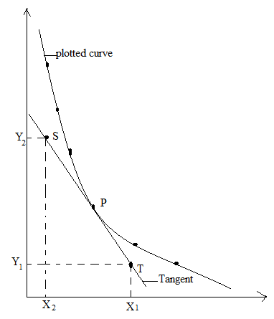
TYPES OF GRAPHS
- Straight line graphs
If a straight line graph is obtained, its equation is in form of y = mx + c.
Where m is the slope of the line. From the diagram below
Slope, m =$\frac{AB}{BC}$
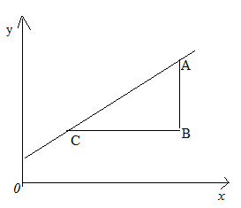

- Non – linear graph
- An inverse proportion graph
Suppose y α$\frac{1}{x}$ where yx = a constant. If a graph is plotted of y against x, it will look like
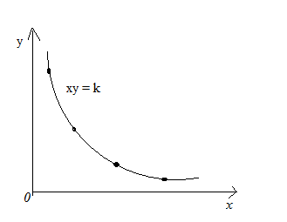

ii) A square law graph
A square law graph is obtained by plotting y against x from the equation y = kx²
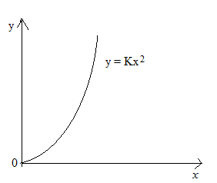

iii) An inverse square law graph
This has got an equation in form y =$\frac{K}{X^{2}}$
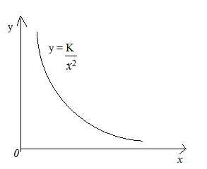
- Log graph
When finding relationship between two quantities i.e. x and y experimentally assuming
y = Kx^{n} where Kis a constant, we can take logs
logy =logK + n logx
in form of y = mx+c, a graph of logy against logx will be plotted, n will be the gradient.
A straight line is obtained andlogK is an intercept on logy axis hence K and n can be found.
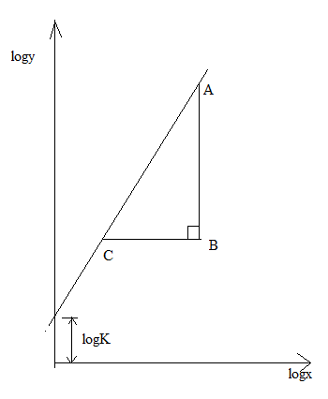
n = $\frac{AB}{BC}$

Qualities of a good graph
- It should have a title.
- It should have axes well labeled.
- Scale covering three quarters of the graph paper.
Title
Any graph must have a title or heading written at the top of the graph paper and well double underlined egA graph of T² against l.
This means T is on the vertical axis and l on the horizontal axis.
Units should not be put in the title of the graph.

Axes
Both the vertical and horizontal axes have to be drown perpendicular to each other.
Axes should be drawn using solid lines and with continuing arrows at the extreme ends from the meeting point or origin.
Each axis should be labeled with the symbol of the quantity used in the title, the followed by appropriate units in curved brackets.
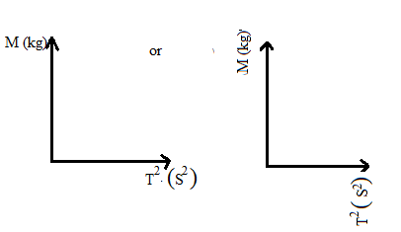

- Scale
It has been noted that student find a lot of difficult when plotting values on the graph. the may be attributed to use of inconvenient scales.
When plotting values on a graph, the scales used must be :
- Cover at least 50% of the graph paper on both axes 12cm (6big squares) on the vertical axis an 10cm(5big squares) on the horizontal axis for UNEB(type) graph papers.
- Be uniform
- Be suitable and convenient
The scales must be multiples 1, 2,2.5 and 5 e.g.
0.1 0.2 0.25 0.5
0.01 0.02 0.025 0.05
0.001 0.002 0.0025 0.005
1 2 2.5 5
10 20 25 50
100 200 250 500 etc

Note: a scale of 2.5 may also be used but it is not a very convenient as 1, 2 and 5
The scales above and other scales that can be generated from the digits 1, 2, 2.5 and 5 constitute a set of convenient scales.
Scales based on digits 4, 6, 7 and 8 are not convenient and should not be used.
NB: for easy plotting, the scales must be in terms of what 1(one) small square represents.
How to obtain a convenient scale from values
Consider the table of results below.
$$t=time for 20 oscillation$$
$$l(m)$$ | $$t(s)$$ | $$T(s)$$ | $$T^{2}(m^{2})$$
0.900 | 37.0 | 1.85 | 3.42
0.800 | 36.0 | 1.80 | 3.24
0.700 | 34.0 | 1.73 | 2.99
0.600 | 32.0 | 1.60 | 2.56
0.500 | 29.0 | 1.48 | 2.19
0.400 | 26.0 | 1.30 | 1.69
0.300 | 23.0 | 1.15 | 1.32
Soln
Vertical scale(T²-axis)
Range =3.42-1.32
= 2.10
- (10 big square (20cm) = 2.10
- 1 big square (2cm or 10 small squares)=$\frac{2.10}{10}=0.21$
Since 0.21 lies between 0.2 and 0.5 from the set of convenient scales, for suitable we shall take 0.5 and not 0.2 as our convenient scale.
Thus 1 big square (2cm or 10 small square)=0.5 and 1 small square=0.05
NB. Ifthe scale obtained after dividing the range by the number of a big square on the axis is not convenient scale s but lies between two convenient scales, for suitability, take the upper convenient scales e.g. if the scale obtained is 2cm {10 small squares} = 0.132,since this scale between 0.1 and 0.2 from the rest of convenient scales, for suitability, we use a scale of 2cm to represent 0.2 and not 1.0.
Horizontal scale$(l-axis)$
Note: if the values to be plotted are increasing or decreasing uniformly like in the case for $l$ ,it may not be necessary to calculate the scale the way we did for the values of T2. Foe such values, its possible to choose a suitable and convenient scale without calculating.
In this case we can use a scale of a big square (2cm or 10 small squares) to represent 0.4.
- 1 small square will represent 0.01.
However, its advisable to calculate the scale if you are not sure of the scale to use. This can be done as follows;
Range = 0.90 – 0.30
= 0.60
- 8 big square =$\frac{0.60}{8}=0.075$
Since 0.075 lies between 0.05 and 0.1 from the set of convenient scales, we shall use a scale of;
1 big square = 0.1
1 small square = 0.01
Plotting
Signs that are acceptable in plotting point include ;
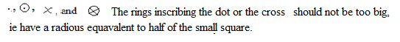
Drawing the line of best fit or trend line
The line of best fit is a straight line that best represent the data on a scatter plot.
The line may;
- Pass through most of the points or all or the points as in the illustrations below.
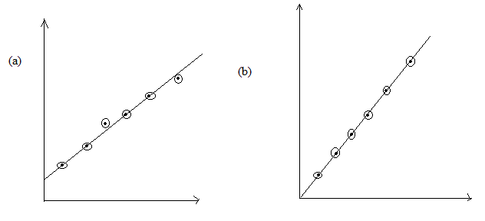
- For scattered points where a line can not pass through all or most of the points, line of best fit has to be drown passing in the middle of all points. However the points must be evenly distributed on either sides.
Illustration

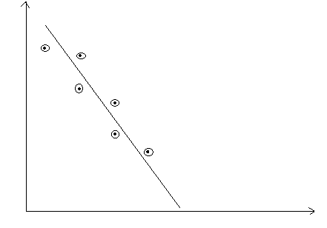
Finding slope of the graph
For straight line graph;
- Draw a large right angled triangle covering all the points touching the line of best fit produced beyond the plotted points.
- Read the co-ordinates of the triangle and record the values before calculations.
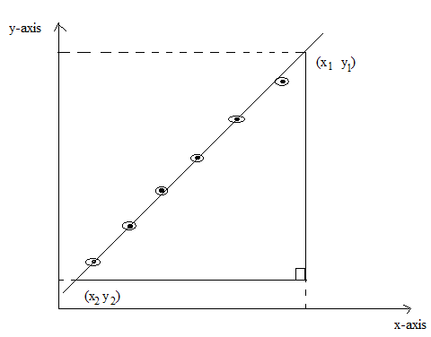
Slope = change in y values
change in x values
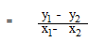

Units of the slope
The unit of the slope is derived from the units of the values on the axes of the graph.
If a graph of V against I was plotted, then the unit of the slope is VA⁻¹.
Intercept.
Intercept here we refer to X- intercept (horizontal intercept) and Y- intercept (vertical intercept).
X - intercept (horizontal intercept is a point where a line of best fit or the curve crosses the X-axis and the value of the Y value is zero at that point. If in the question the horizontal intercept is needed, then the values on the Y- axis have to start from zero.
Y- intercept (vertical intercept) is a point where a line of best fit or curve crosses the Y-axis and the X value is zero at that point. For vertical intercept, the values on the X-axis have to start from zero.
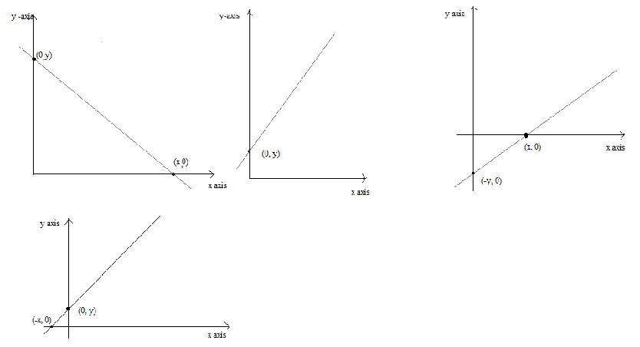
Units of the quantity or constant determined.
The unit of a constant or quantity to be determined should be obtained from the substitution of the slope or other quantities substituted in the expression.
Example
- Calculate the constant ℓof the mass, Y, from;
ℓ = Sx₀( x₀= 0.002m, S = 3.456kgm⁻¹ )
- Calculate g from;
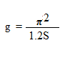( π = 3.14, S = 0.822s²m⁻¹ )
However for a quantity, it should bare its SI unit like determining mass should bare units of kg or g, acceleration due to gravity it should bare units of ms⁻².

TREATMENT OF ERRORS
Types of errors
- Systematic error
This may be due incorrect calibration scale, for example a meter rule or voltmeter.
Repeating the observation does not help the existence of the error and may not be suspected until the final result is calculated and checked, say by different experimental method.
If the systematic error is very small, a measurement is accurate.
- A random error
A random error arises in any measurement, usually when the observer has to estimate the last figure, possibly with instruments that lacks sensitivity.
Random errors are small for a good experiment and taking mean of the number of separate measurements reduces them.
A measurement with a small random error is precise but may not be accurate as there may be a systematic error.

ESTIMATING ERRORS IN SINGLE MEASUREMENT
Example 1
If using a meter rule, the length of an object is measured as 10.4cm, to the worst the answer might be measured as 10.3 or 10.5cm.
This implies the possible error made by using a meter rule is ± 0.1cm.
This length will be written as (10.4 ± 0.1)cm
The percentage possible error (p.p.e) = $\frac{0.1X 100}{23}$ = ±0.4%.
Example 2
Using a verniercaliper capable of measuring the length of an object, for example if the length may be (2.46 ± 0.01)cm. in this case the possible error is ±0.01cm and the possible percentage error is $\frac{0.01X 100}{23}$ = ±0.4%.
Combining errors
The result of the experiment is usually calculated from an expression containing the different quantities measured .
The combined effect error win various measurements has to be estimated.
- Sum(addition)
Suppose W= x + y where x and y are measured quantities
The total possible error in W = (P.e in x) + (p.e in y)
If x = (2.1 ± 0.1) and y = (4.5±0.1)cm measured using a meter rule
Then W = (6.6 ± 0.2)cm which means at worst W = 6.8cm or 6.4cm
- Difference (subtraction)
The same rule applies
W = y - x
p.e in W = (P.e in x) + (p.e in y) , if y = (5.6 ±0.1)cm and x = (3.4± 0.1)cm
W = (5.6 ± 0.1) – (3.4± 0.1)cm
= (2.2 ±0.2)cm
To the worst, W = 2.4cm or 2.0cm
- Product and quotient
Suppose a , b and c are measured quantizes

From the expression W = $\frac{{ab}^{2}}{c^{\frac{1}{2}}}$
Then if p.pe in a is ±2%, in b is ±1% and in c is ±2%
p.pe in a b² 2(±1)% = ±2% and in $c^{\frac{1}{2}}$ = $\frac{1}{2}(±2)\%$ = ±1%
then total p.pe in W = ±(p.pe in a + p.pe in b²+ p.pe in $c^{\frac{1}{2}})$
= ±(2+2+1) = ±5%
The answer for W will be therefore be accurate to 1 part in 20 and if the numerical result of W is 2.5
Then it is written as 2.5 ± ($\frac{1}{20}X 2.5)$ = 2.5 ± 0.1.
Note:
For measured quantities divided or multiplied, the total p.pe equals the sum of the separate p.pe.
(p.pe is percentage possible error)

EXPERIMENT 1
In this experiment you will determine the mass of a meter rule provided.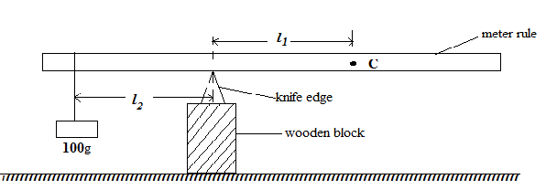
- Place the block of wood on the table so that it rests on its smallest cross section area.
- Place the knife edge on top of the block.
- Without the mass, balance the meter rule provided on the knife edge with its calibrated face upwards.
- Record the position C at which the meter rule balances.
- Suspend a 100g mass at the 2cm mark and adjust the rule until it balances again.
- Determine the distance l₁ and l₂of C and the weight respectively from the knife edge.
- Repeat the procedures e) to f) with the weight hanging from the 6, 10, 14, 18 and 22cm marks.
- Record your results in a suitable table.
- Plot a graph of l₁(along vertical axis) against l₂ (along horizontal axis)
- Find the slope, S, of your graph.
- Calculate the mass, M, from the expression.
M = 100S

EXPERIMENT 2
PART 1
In this experiment you will determine the force constant K, of the spring provided
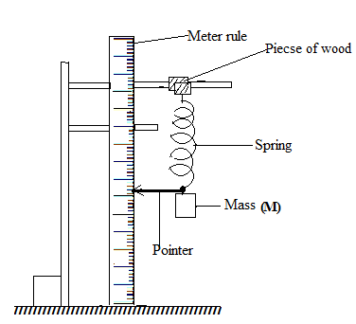
- Clamp the upper hook of the spring using the two pieces of wood provided, as in the figure above. Make sure that the spring is vertical .
- Attach a pointer to the free end of the spring. Read and record the position, X₀ (in metres)
- Suspend a mass M, of 0.100kg from the lower end of the spring.
- Read and record the new position, X, (in metres) of the pointer.
- Repeat procedures (b) to (d) for values of M = 0.200, .300, 0.400, 0.500 and 0.600kg.
- Record all your results in a suitable table including values of (X-X₀)
- Plot the graph of (X-X₀) against M.
- Find the slope, s₁, of the graph.
- Determine the force constant, K of the spring from K= $\frac{g}{S_{1}}$; where g= 9.81ms⁻²
PART 2
In this experiment you will determine the effective mass, m₀, of the spring.
- Suspend the mass, M, of 0.100kg from the spring as in part 1,
- Pull the mass vertically downwards through a small displacement and release it.
- Measure the time t, for 20 oscillations of the mass.
- Repeat procedures (a) to (c) for M = 0.200, 0.300, 0.400, 0.500 and 0.600 kg
- Record all your results in a suitable table including values $\frac{ 1}{f^{2}}$where f = $\frac{20}{t}$.
- Plot a graph of$\frac{ 1}{f^{2}}$ against M.
- Determine the slope, S₂, of the graph.
- Determine from the graph, the intercept, C on the $\frac{ 1}{f^{2}}$ axis
- Calculate the effective mass, m₀of the spring from$m_{0}=\frac{C}{S_{2}}$

EXPERIMENT 3
In this experiment you will determine the relative density S, of the material of solid x provided

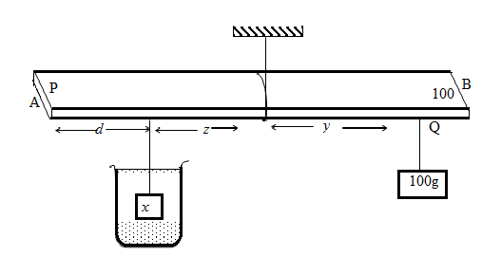

- Record the mass, M of the solid x provided
- Suspend a metre rule from a clamp using a piece of thread
- Adjust the metre rule until it balances horizontally
- Read and record the distance of the balance point, P of the rule from end A
- Suspend the solid x at a distance d = 10cm from end A of the metre rule
- Immerse solid x completely in water in the beaker.
- Suspend a 100g mass from a point Q between P and B
- Adjust the position of Q until the metre rule balances horizontally, with x completely immersed and not touching the mug as shown in the figure above.
- Measure and record distances z and y
- Repeat procedure (e) (i) for values of d = 15,20,25,30 and 35cm.
- Enter your results in a suitable table
- Plot a graph of z against y
- Find the slope S, of the graph
- Calculate the relative density S, of the material from the expression ρ =

$$ρ= \frac{M}{M-100S}$$

EXPERIMENT 4
In the experiment you will determine the mass m of the plastic bottle provided
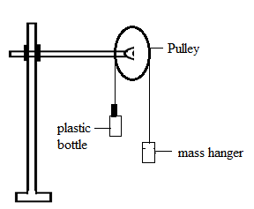

- Clamp the pulley vertically using the retort stand as shown above.
- Tie the string around the neck of the plastic bottle provided.
- Pass the string the string over the pulley and attach its free end to the 50g mass hanger placed on the bench.
- Pour a little of water into the plastic bottle in a small amount until the mass hanger is just raised completely off the bench.
- Empty the water and in the plastic bottle into a measuring cylinder.
- Read and record the volume V of the water.
- Repeat procedures b) to f) for mass m = 100, 150, 200, 250 and 300g on the hanger.
- Enter your results in a suitable table.
- Plot a graph of V against m.
- Find the slope S of your graph.
- Read and record the value of the intercept I₀ on the V axis.
- Determine the mass of the plastic bottle from M = $-\frac{I_{0}}{S}$.

EXPERIMENT 5
In this experiment you will determine,
- The mass, M_{L}, of a loaded metre rule; and
- The relative density of rubber.

PART 1

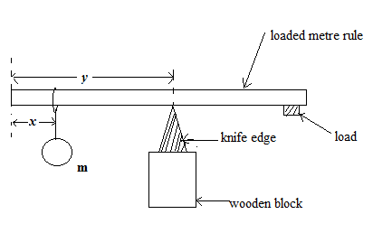
- Suspend a mass m =100g at a distance, x = 10.0 cm from the zero end of the metre rule.
- Balance the metre rule on the knife edge with its graduated face upwards as shown in figure above.
- Measure and record the distance y of the knife edge from the zero end of the metre rule.
- Repeat the procedures (a) to (c) for values of x = 15.0, 20.0, 25.0, 30.0, 35.0 and 40.0cm.
- Tabulate your results.
- Plot a graph of y against x.
- Find the slope, S, of your graph.
- Read the intercept C, on they-axis
- Calculate the mass M_{L} , of the loaded metre rule from the expression:
M_{L} = $m\left(\frac{1}{S}-1\right)$

- Calculate the distance, D, of the centre of mass of the loaded metre rule from zero end using the expression:
C = $\frac{M_{L}D}{M + M_{L}}$

PART 2
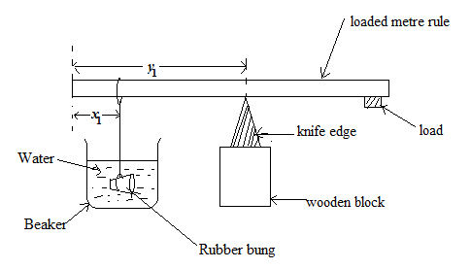
- Record the Mass, M_{s}, of the rubber bung provided.
- Suspend the rubber bung at a distance x₁ = 15.0 cm from the zero end of the meter rule.
- With the rubber bung wholly immersed in water, balance the meter rule on the knife edge with its graduated face upwards as shown in figure above.
- Measure and record the distance, y₁.
- Repeat procedures (b) to (d) with the rubber bung at a distance x₂= 30.0 cm from the zero end of the meter rule and record the corresponding distance, y₂.
- Calculate the mass M’_{s} from the expression:

M’_{s} = 0.5M_{L}(D- y₁) + (D- y₂)
(y₁ – x₁) (y₂ – x₂)
- Calculate the relative density, ρ, of rubber from the expression,
Ρ = M_{S}
M_{S} – M’_{S}

EXPERIMENT 6
In the experiment you will determine the relative density, R.D of liquid L provided using two methods.
PART1
- Clamp a meter rule vertically and suspend the spring with the pointer attached beside the ruler.
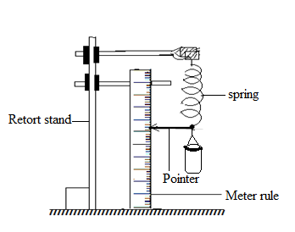
- Suspend the beaker with a knitting thread as shown above and record the initial position of the pointer on the meter ruler.
- Pour 100cm³ of water into the beaker and record the new position of the pointer. find the extension y in meters.
- Remove the beaker, empty, dry and suspend it.
- Repeat procedures (c) using liquid, L and find the extension, x.
- Calculate the relative density from the expression, R.D = $\frac{X}{y}$.

PART 11
- Record the mass M_{b} and M_{r} or the rubber bung and the meter rule provided respectively.
- Suspend the meter rule provided on a retort stand using a thread balance it horizontally with its graduated face upwards. Record the position of balance point, G.
- Suspend the rubber bung P at a distance l = 5.0cm from the zero end of the meter rule as shown below.
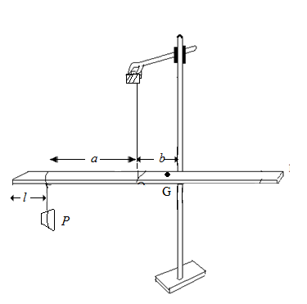
- Wholly submerge the rubber bung in water, provided in the beaker.
- Adjust the position of the loop until the meter rule balances horizontally.
- Measure and record the distances a and b of the rubber bung and point G, from the thread, respectively.
- Repeat procedures c) to f) for l = 10.0, 15.0, 20.0, 25.0 and 30.0cm.
- Tabulate your results including values of x =(aM_{b} – bM_{r}) and $\frac{X}{a}$.
- Repeat procedures c) to f) and g) with the rubber bung wholly immersed in liquid , L provided.
- Measure and record the distances c and d of the rubber bung and point G, from the thread, respectively.
- Tabulate your results including values of x =(cM_{b} – dM_{r}) and $\frac{y}{c}$.
- Plot a graph of $\frac{y}{c}$ against $\frac{X}{a}$ .
- Find the slope R.D of your graph.

EXPERIMENT 7
In the experiment you will determine the force constant K of the spiral spring provided.
PART I
- Place the meter rule on a knife edge with its graduated face upwards And locate its center of gravity, C.
- Using cellotape, attach an optical pin at one end of the meter rule to act as a pointer.
- Tie one of the spring on a meter rule at the 99.0cm mark.
- Suspend the spring by tying the free end to the rod of the clamp.
- Support the other end of the meter rule on a knife edge as shown in the figure bellow.
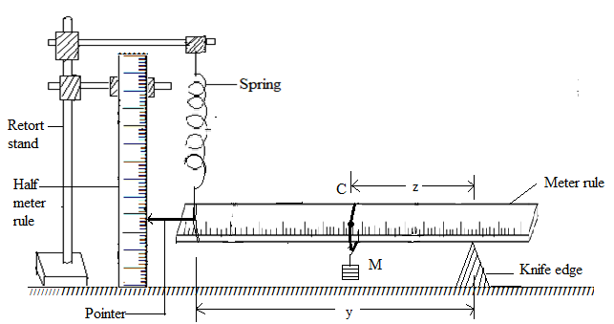
- Adeju8st the position of the knife edge until the meter rule balances horizontally and the spring vertically.
- Read and record the position of the pointer P₀ on the half meter rule.
- Suspend a mass, M = 0.100kg on the meter rule at point C.
- Adjust the position of the knife edge until the meter rule balances horizontally with the spring vertical and the pointer back at its initial position,P₀.
- Read and record the new position of the knife edge, R.
- Measure and record the distance z and y of the mass and the spring respectively from, R.
- Repeat procedures h) to k) for values of M = 0.150, 0.200, 0.250, 0.300 and 0.350kg.
- Tabulate your results in a suitable table including values of $\frac{y}{z}$.
- Plot a graph of M against $\frac{y}{z}$.
- Find the slope, S of the graph.

PART II
- Attach a pointer to one end of the spring provided using a thread.
- Suspend the spring from the free end by tying it on the rod of the retort stand clamp.
- Clamp the half meter rule as shown the figure below.
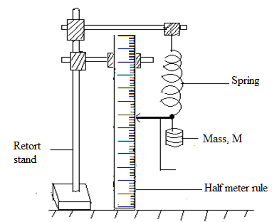
- Read and record the position of the pointer y₀ in meters on the half meter rule.
- Suspend a mass M = 0.200kg from the spring.
- Read and record the new position of the pointer y in meters.
- Find the extension, y₁= (y – y₀).
- Pull the mass vertically downwards through a small distance and release it to oscillate .
- Measure the time for 20 oscillations.
- Find the period, T₁.
- Repeat the procedure d) to g) for M = 0.300kg and find y₂ and the period T₂.
- Find the value of G from the expression,
G = 4π²y₂ – y₁
T₂² – T₁²
- Calculate K from the expression
K = $\frac{SG}{е}$ where e = 0.0221m.

EXPERIMENT 8
In this experiment, you will determine the constant, w, of the spring provided.
- Determine the radius, r, of the wire of the spring in metres.
- Determine the radius, R, of the spring in metres.
- Record the number of turns, N, of the spring.
- Clamp the spring provided and the half meter rule as shown in the figure below.
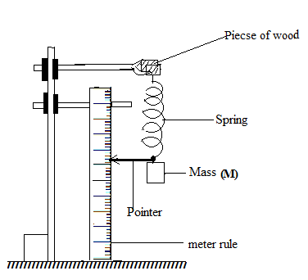
(e) Read and record the initial position of the pointer on the half metre rule.
(f) Suspend a mass M = 0.200kg from the spring.
(g) Read and record the new position of the pointer and find the extension, x, of the spring.
(i) Pull the mass vertically downwards through a small distance and release it to oscillate.
(j) Determine the time, t for 20 oscillations and the period, T.
(l) Repeat procedures (f) to (k) for values of M = 0.300, 0.400, 0.500, 0.600, and 0.700kg.
(m) Tabulate yourresults including values of T²and plot a graph of M against x..
(o) Find the slope S₁, of the graph.
(p) Calculate ∩₁ from ∩₁=4gNR³S₁g where g = 9.8 ms⁻²
r⁴
(q) Plot a graph of T²against M and find the slope, S₂ of the graph.
(s) Calculate ∩₂, from ∩₂=$\frac{160NR^{3}}{S_{2}r^{4}}$
(t) Find the constant, w, from w = $\frac{1}{2}$(∩₁+∩₂)

EXPERIMENT 9
In this experiment you will determine the force constant K, of the spring provided
PART 1
- Clamp the upper hook of the spring using the two pieces of wood provided, as in the figure above. Make sure that the spring is vertical .
- Attach a pointer to the free end of the spring. Read and record the position, X₀ (in metres)
- Suspend a mass M, of 0.100kg from the lower end of the spring.
- Read and record the new position, X, (in metres) of the pointer.
- Repeat procedures (c) to (d) for values of M = 0.200, .300, 0.400, 0.500 and 0.600kg.
- Record all your results in a suitable table including values of (X-X₀)
- Plot the graph of (X-X₀) against M and find the slope, s₁, of the graph.
- Determine the force constant, K of the spring from K= $\frac{g}{S_{1}}$; where g = 9.81ms⁻²
PART 2
In this experiment you will determine the effective mass, m₀, of the spring.
- Suspend the mass, M, of 0.100kg from the spring as in part 1,
- Pull the mass vertically downwards through a small displacement and release it.
- Measure the time t, for 20 oscillations of the mass.
- Repeat procedures (a) to (c) for M = 0.200, 0.300, 0.400, 0.500 and 0.600 kg
- Record all your results in a suitable table including values$\frac{1}{f^{2}}$ where f =$\frac{20}{t}$.
- Plot a graph of $\frac{1}{f^{2}}$ against M and determine the slope, S₂, of the graph.
- Determine from the graph, the intercept, C on the $\frac{1}{f^{2}}$axis.
- Calculate the effective mass, m₀of the spring from
m₀ = $\frac{C}{S_{2}}$

EXPERIMENT 10
In an experiment you will determine the relative density of material of a rod.
- Fix a centimeter scale on the outside of 500ml beaker.
- Place water in the beaker about thirds full.
- Measure and record the length lof the rod provided.
- Suspend the metal rod from the spring balance with height h = 1.0cm immersed in the water in the beaker as shown.
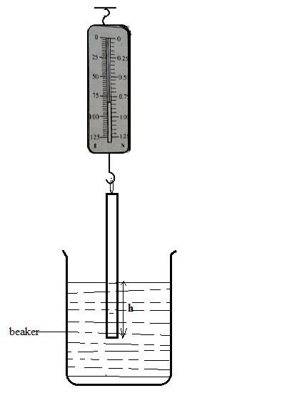
- Record the reading W of the spring balance.
- Repeat procedures d) to e) for h = 2.0, 3.0, 4.0, 5.0 and 6.0cm.
- Tabulate your results
- Plot a graph of W against h.
- Find the slope S of your graph and the intercept C on the h-axis.
- Calculate the relative density of the material from
$$P = -\frac{1}{l}\left(\frac{c}{s}\right)$$

EXPERIMENT 11
In the experiment you will determine the Young’s modulus of wood using cantilever
- Project a meter rule along the top of a bench with its graduated face upwards with length
l = 80cm projected beyond the edge of the bench with a pointer attached at the end as shown below

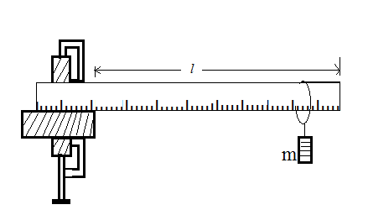

- Suspend a mass, m of 0.05kg at a distance of 1.0cm from the free end.
- Depress the mass, m through a small vertical distance and release it to oscillate. Measure and record the time for 20 oscillations hence the periodic time T.
- Repeat procedures in c) for values of m = 0.100, 0.150, 0.200, 0.300, and 0.350kg
- Tabulate your results including values of T².
- Plot a graph of T² against m.
- Find the slope S of your graph.
- Determine the breadth, b and thickness, t of the meter rule.
- Calculate young’s modulus for the wood material from the expression
$$Y=\frac{16π^{2}}{Sb}{\left(\frac{l}{t}\right)}^{3}$$

EXPERIMENT 12
In the experiment you will determine the Young’s modulus of wood using cantilever
- Project a meter rule along the top of a bench with its graduated face upwards with length
l = 80cm projected beyond the edge of the bench with a pointer attached at the end as shown below
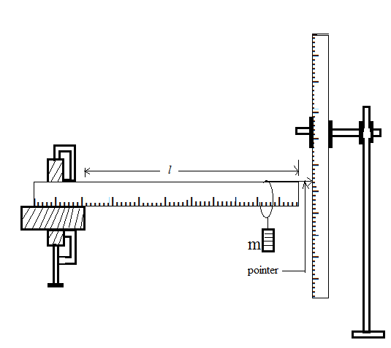

- Note and record the initial position of the pointer on the meter rule clamped vertically on the retort stand.
- Suspend a mass, m of 0.05kg at a distance of 1.0cm from the free end. Note the new position of the pointer.
- Determine the depression, d in meters of the pointer .
- Repeat procedures c) to d) for values of m = 0.100, 0.200, 0.250, 0.300,0.350 and 0.400kg
- Tabulate your results
- Plot a graph of d against m.
- Find the slope S of your graph.
- Determine the breadth, b and thickness, t of the meter rule.
- Calculate young’s modulus for the wood material from the expression
$$Y=\frac{4g}{Sb}{\left(\frac{l}{t}\right)}^{3}$$

EXPERIEMENT 13
In this experiment, you will determine Young’s modulus, Y of wood provided.

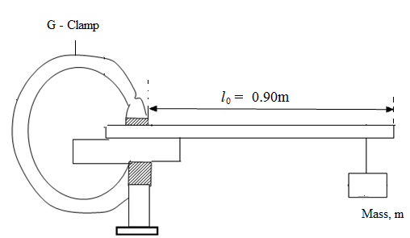

METHOD 1
- Measure and record the thickness, d and breadth, b, of the metre rule.
- Find P form the expression
P = 16$π^{2}$
bd³
- Clamp the metre rule at the edge of the table leaving a length,l = 0.90m behind the edge of the table as shown in the figure above.
- Suspend the mass, M, of 0.100kg at the free end of the metre rule using the piece of thread provided.
- Depress the mass, M, through a small distance and release it to oscillate.
- Measure the time for 20 oscillations and determine the periodic time T.
- Repeat procedures d) to f) for values of M = 0.200, 0.300, 0.400, 0.500 and 0.600kg.
- Enter your results in a suitable table including values of T².
- Plot a graph of T² against M.
- Find the slope, S₁, of the graph.
- Calculate young’s modulus, Y, from the expression:
Y = Pl³
S₁

METHOD 11

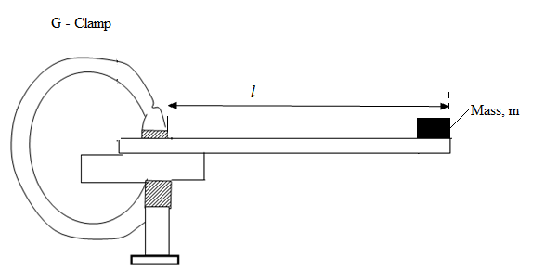
- Remove the masses from the meter rule in part 1.
- Starting with l = 0.90m, place a mass M = 0.400kg at the end of the meter rule as shown in the figure above.
- Depress the mass through a smaller distance and release it to oscillate.
- Measure the time for 20 oscillation and the determine the period, T.
- Repeat procedure b) to d) for values of l = 0.80, 0,70, 0.60, 0.50 and 0.40m.
- Record your results in a suitable table including values of T² and l³.
- Plot a graph of T² against l³.
- Find the slope, S_{2,} of the graph.
- Calculate young’s modulus, Y, from the expression.
Y =$\frac{PM}{S_{2}}$

EXPERIMENT 14
In this experiment you will determine the moment of inertia I of metre rule B by two methods.
Method 1
- Weigh the metre rule B and record its mass M.
- Clamp metre rule A horizontally with the scale facing you.
- Tie one piece of thread at the 5.0cm mark and another at the 95.0cm mark of metre rule A.
- Suspend metre rule B from the clamped metre rule as shown in figure 1. Make sure the scale of metre rule B faces upwards.
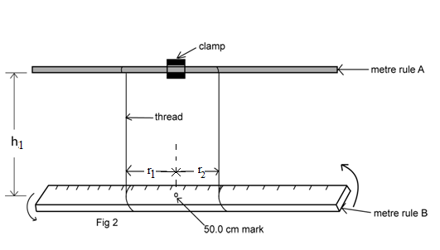

- Adjust the length h₁ of the pieces of thread to 0.500m.
- Turn metre rule B through a small angle about a vertical axis through the centre and release it to oscillate.
- Measure and record the time for 20 oscillations.
- Determine the period, T, of oscillation.
- Calculate the value of I₁ from the expression :
I₁=$\frac{Mgr_{1}^{2}T^{2}}{4π^{2}h_{1}}$Where $π$ =3.14, g = 9.81ms⁻²
r₁ = the distance of either pieces of thread from the 50.0 cm mark of metre rule

METHOD 11
- Set up the apparatus as shown in figure 2.

- Adjust distance X to 0.100m.Ensure that the threads are parallel and equidistant from the 50.0 cm mark of metre rule B.
- Turn metre rule B through a small angle about vertical axis through the centre and release it to oscillate.
- Measure and record the time for 20 oscillations.
- Determine the period, T, of oscillation.
- Repeat procedures (b) to (e) for values of X =0.150, 0.200, 0.250, 0.300 and 0.350m.
- Tabulate your results including values of $\frac{1}{X^{2}}$ and T²
- Plot a graph of T² against $\frac{1}{X^{2}}$
- Determine the slope S of the graph.
- Calculate the value of I₂ from the expression:
I₂= $\frac{MSg}{16π^{2}h_{2}}$
- Calculate the moment of inertia I of metre rule B from the expression:
I = $\frac{I_{1}+I_{2}}{2}$

EXPERIMENT 15
In this experiment, you will determine the constant K of the wooden beam provided. Set up the apparatus as shown below
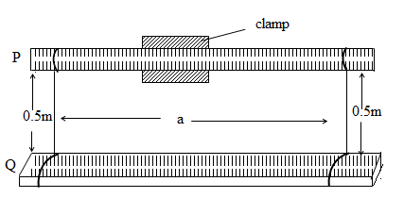

- Clamp the beam p horizontally with the scale facing you.
- Tie one piece of thread at the 5cm mark and another at the 95cm mark of P.
- Suspend the second beam Q (with its scale facing upwards) from the clamped beam P.
- Adjust the distance a between the threads on the beam Q to 0.90 m.
- Give Q a small displacement in the vertical plane in which it lies
- Measure the time for 20 oscillations
- Find the period T₁, of the oscillations
- Give Q a small angular displacement about a vertical axis through its centre.
- Measure the time for 20 rotational oscillations.
- Find the period T₂, of the rotational oscillations.
- Keeping the position of the thread tied to P fixed, repeat procedures (f) to (j) for values of a = 0.80, 0.70, 0.60, 0.50 and 0.40m.
- Tabulate your results including values of $\frac{T_{1}}{a}$
- Plot a graph of $\frac{T_{1}}{a}$ against T₂
- Use your graph to find K from: Ka = $\frac{T_{1}}{T_{2}}$

EXPERIMENT 16
In the experiment, you will determine the moment of inertia of a meter rule X, about its center by two methods.
METHOD I
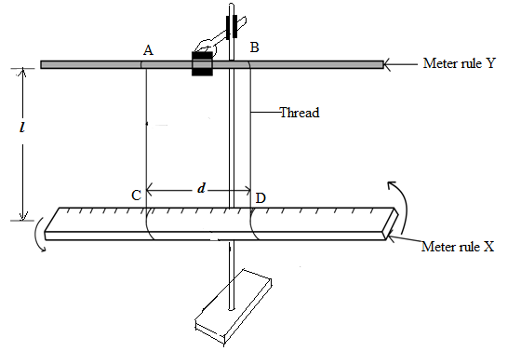
- Read and record the mass, M, of the meter rule labeled X.
- Clamp the meter rule labeled Y as shown in the figure above.
- Tie threads AC and BD at the 35.0cm and 65.0cm marks of the meter rule X, such that they are at separation, d.
- Adjust the length, l, of each thread to 0.500m.
- Displace the meter rule X, about the vertical through its centre and release it to oscillate in the horizontal plane.
- Record the time for twenty oscillations.
- Calculate the period T.
- Calculate the moment of inertia, I.
I =$\frac{Mg}{{16π}^{2}l}{(Td)}^{2}$
whereg, is acceleration due to gravity (9.8m⁻²)

METHOD II
- Dismantle the arrangement in the figure above in method 1.
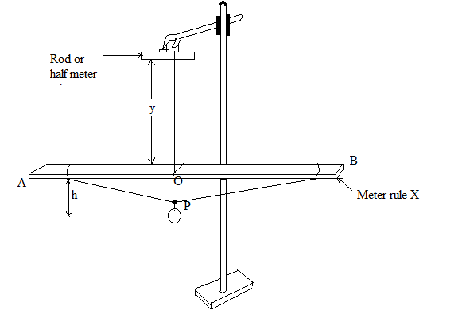
- Suspend the meter rule X using a piece of thread such that length y = 2.5cm as show in the figure above.
- Adjust the position o such that the meter rule balances horizontally.
- Tie one end of the long thread provided at the 1.0cm mark of meter rule X.
- Pass the other end of the thread through a hook of a pendulum bob provided and tie the free end of the thread at the 99.0cm mark.
- Adjust the height, h, to 0.600m.
- Adjust the position of the hook along the thread, so that the meter rule balances again.
- Displace the end A of the meter rule and release it to oscillate in vertical plane.
- Record the time for 10 oscillations
- Calculate the period T₁.
- Stop the oscillation of the meter rule.
- Displace the pendulum bob towards you and release to oscillate in a horizontal plane perpendicular to plane APB.
- Record the time for 10 oscillations.
- Calculate the periodic time T₂.
- Repeat procedures f) to n) values of h = 0.500, 0.400, 0.300 and 0.100m.
- Tabulate your results including values of T₁², T₂², (T₁² – T₂²) and $\frac{1}{h}$.
- Plot a graph of (T₁² – T₂²) against$\frac{1}{h}$.
- Determine the slope, S of the graph.
- Find the moment of inertia, I, from:
S = $\frac{{4π}^{2}I}{gm}$where g = 9.8ms⁻² and m is the mass of the pendulum bob provided.

EXPERIMENT 17
In the experiment you will determine the radius of gyration of a wooden beam
- Using a knife edge, determine the center of mass, G of meter rule with holes drilled in it.
- Clamp a cork with pin passing through it so that the pin is horizontal.
- Suspend the meter rule on a pin from the hole nearest to G. measure and record the length l from the G as shown below.
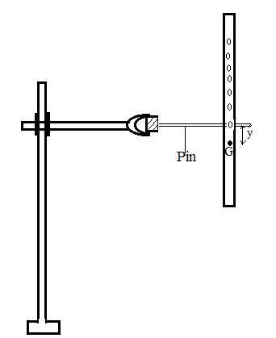
- Displace the beam through a small angle with the vertical axis and release to oscillate. Determine the time, t for 20 oscillations in the vertical plane, hence the period T of the beam.
- Repeat procedures b) to c) with the beam suspended from successive holes.
- Tabulate your results including values T² and l². Plot a graph of T against l and use it to determine the value of l₀for which T is minimum.
- Find the value g₁ of the acceleration due to gravity using the expression;$g_{1} = \frac{8π^{2}l_{0}}{T_{0}^{2}}$.
- Plot a graph of T²l against l². Find the slope S and intercept C of your graph.
- Find the value of g₂ of the acceleration due to gravity using the expression; $g_{2 }=\frac{4π}{S}$.
- Calculate the mean value g of g₁and g₂.
- Find the radius of gyration, K of the meter rule using the equation$K=\sqrt{\frac{Cg}{4π^{2}}}$.

EXPERIMENT 18
In the experiment you will determine the constant, K, of the meter rule, Q, using two methods.
METHOD 1

- Measure and record the thickness, t, and breadth, d, of the meter rule labeled Q.
- Balance the meter rule, Q, on a knife edge and determine its center of gravity, C.
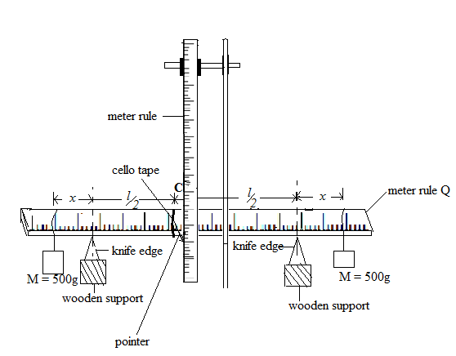
- Attach a pointer to the meter rule using a piece of cello tape at point, C.
- Support the meter rule on the knife edge with its graduated face facing upwards such that the distance from the knife edge to C, $\frac{l}{2}$= 0.40m as shown in the figure above.
- Clamp a meter rule vertically using a retort stand and place near a pointer.
- Read and record the position of the pointer, P_{o}.
- Suspend a mass M =50g at a distance x = 0.075m from the each of the knife edge.
- Read and record the new position of the pointer, P₁.
- Determine the change, h, in the position of the pointer.
- Repeat procedures d) to i) for values$\frac{l}{2}$= 0.35, 0.25 and 0.20m. keeping masses , M constant and fixed in their positions, record the values of x in each case.
- Enter your results in a suitable table including values $\frac{h}{x}$and l².
- Plot a graph of $\frac{h}{x}$against l².
- Determine the slope, S, of the graph.
- Calculate the constant, K, of the meter rule, Q, from the expression:
S =$\frac{r}{Kdt^{3}}$where r = 7.35Nm⁻¹s²

METHODE II
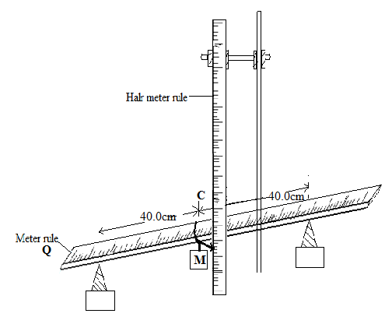
- Remove the masses, M.
- Adjust the position of the knife edges such that each is at a distance 0.40m from C.
- Read and record theposition, P₀, of the pointer.
- Suspend a mass M =0 .500kg at C and record the new position of the pointer, P₁, as shown in the figure above.
- Determine the depression, D, in meters.
- Calculate the constant, K, of the meter rule Q from:
D =$\frac{{Ml}^{3}}{{4Kdt}^{3}}$where g = 9.81ms⁻²

EXPERIMENT 19
In the experiment you will determine the modulus of rigidity, G, of a wire by the methods of torsional oscillations using a meter rule.
- Suspend the meter rule by clamping the torsion head in the retort stand.
- Place two 100g masses on the bar such that each is at a distance, d = 0.5m from the centre of the meter rule as shown in the figure below.
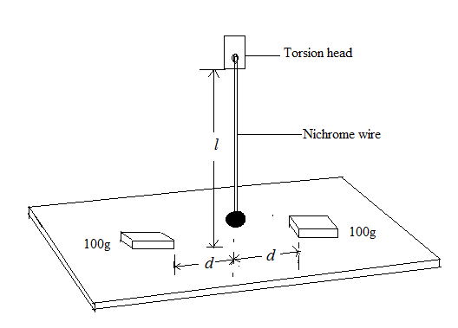
- Twist the meter rule through a small angle and release it to oscillate.
- Determine the time for 10 oscillations.
- Find the period, T for the oscillations.
- Repeat the procedures b) to e) for values of d = 0.10, 0.15, 0.20, 0.25 and 0.30m.
- Tabulate your results including values of T² and d².
- Plot a graph of T² against d².
- Find the slope, S, of your graph.
- Measure and record the length l of the suspension wire.
- Determine the radius, r, of the wire.
- Calculate the modulus of rigidity, G, of the wire using the expression:
G =$\frac{6πMl}{{Sr}^{4}}$where M is the sum in kg of the two masses.
- Remove the masses and repeat procedure d).
- Determine the period T₀, of the oscillations.
- Measure and record the length a and breadthbof the meter rule.
- Record the mass, M₁, of the meter rule.
- Caculate the value if I from the expression:
I = $M_{1\frac{\left(a^{2}+ b^{2}\right)}{l^{2}}}$
- Calculate the value of I from the expression. I = $\frac{T_{0}^{2}M}{S}$
- Compare the values of I obtained in q) and r) above.

EXPERIMENT 20
In the experiment you will determine the young’s modulus, Y, of wood provide.
METHOD I
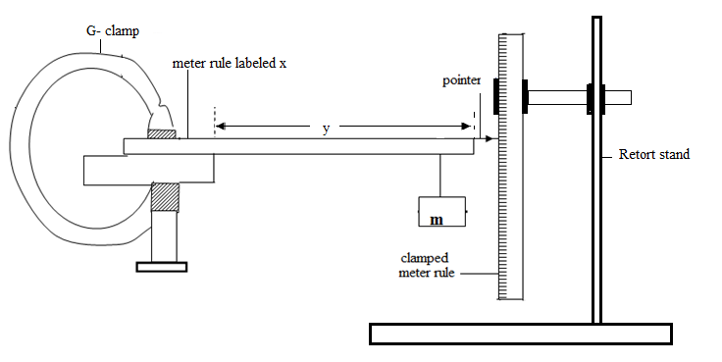

- Measure and record the breadth, b and thickness d of the meter rule labeled x.
- Clamp the meter rule x with a pointer attached at the free end on the table with y = 0.900m from the free end.
- Suspend a mass,m of 0.100kg at a distance 2.0cm from the free end of the meter rule x using a thread.
- Depress the mass through a small distance and release it.
- Measure the time for 20 oscillations and determine the period T₁.
- Calculate the value of E₁, from: E₁ =$\frac{16π^{2}y^{3}}{10T_{1}^{2}{bd}^{3}}$.
- Repeat procedure b) to e) for y = 0.600m and determine period T₂.
- Calculate E₂ from: E₂ =$\frac{16π^{2}y^{3}}{10T_{2}^{2}{bd}^{3}}$.
- Obtain E from: E =$\frac{E_{1 + E_{2 }}}{2}$.

METHOD II
- Using the arrangement in the figure above, with the mass removed, adjust the length, y to 0.900m.
- Read and record the position of the pointer.
- Suspend the mass 0f 0.100kg at a distance 2.0cm from the free end of the meter rule.
- Read and record the new position of the pointer and deter mine the depression x in meters
- Repeat procedures a) to d) for values of y = 0.800, 0.700, 0.600, 0.500, 0.400 and 0.300m.
- Tabulate your results in a suitable table including values of $\log_{10}{x}and\log_{10}{y.}$
- Plot a graph of $\log_{10}{x}against\log_{10}{y.}$
- Read and record the intercept, K on the vertical axis.
- Calculate the value of E from;
K =$\log_{10}\left(\frac{0.4g}{Ebd^{3}}\right)$ where g = 9.81ms⁻¹

EXPERIMENT 21
In this experiment, you will determine Young’s modulus of a wooden beam provided
Method I
- Measure and record thickness t and the width b of the beam
- Place the knife edges such that each is 5 cm from either end of the beam as shown below
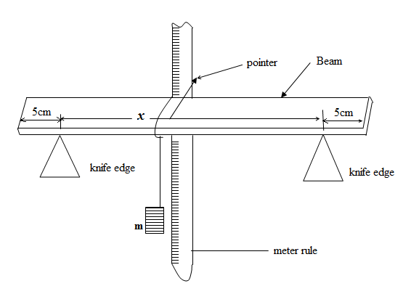
- Tie piece of thread provided from the centre of the beam and suspend a 100g mass hanger from it.
- Read and record the pointer position
- Add a mass m = 0.1 kg to the mass hanger
- Read and record the new pointer position. Hence determine the depression, d, in metres
- Repeat procedures (e) and (f) for values of m = 0.2, 0.3, 0.4, 0.5 and 0.6 kg
- Record your results in a suitable table including values of Z = $\frac{m}{4b}$.
- Plot a graph of Z against d
- Find the slope S of your graph
- Determine Young’s Modulus Y, from the expression Y₁ = S $\left[\frac{x}{t}\right]g$ ; where
g = 9.81 ms^{– 2}

Method II
- Clamp the beam as shown below
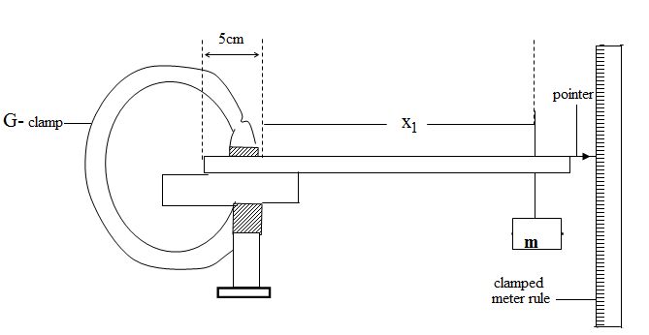
- Place a 0.2 kg mass, m at a distance X₁ = 0.8m and record the depression D₁ of the pointer.
- Repeat (b) above when the mass is placed at a distance x₂ = 0.90m and record the depression D₂ of the pointer.
- Determine Ψ from the expression
Ψ = x³₂ – x³₁
D₂ – D₁
- Calculate Young’s Modulus Y₂ from
Y₂ = 4 Ψ g
5t² b
where t and b are from method I

.

EXPERIMENT 22
In the experiment you will determine the focal length, f of the converging mirror.
- Place the converging mirror on the bench.
- Clamp an optical pin in a cork (using pieces of wood), horizontally in a retort stand, such that its pointed end lies along the axis of the mirror.
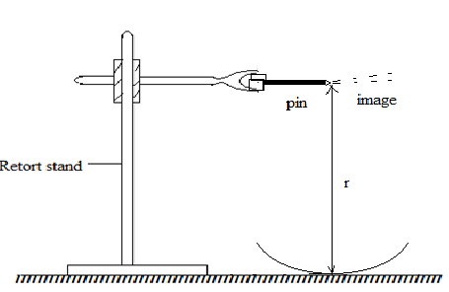
- Adjust the height of the pin above the pole of the mirror until a position is found where the pin coincides with its image. Measure and record distance R of the pin from the pole of the mirror switch no parallax.
- Measure and record the radius of curvature, r of the mirror.
- Displace the pin from the position of coincidence and repeat the procedure in c) to d) to obtain three more values of r. tabulate your results.

- Find the mean radius r_{m} of r.

- Calculate the focal length, f of the mirror from r_{m =} 2f

EXPERIMENT 2 3
In the experiment you will determine the focal length of a converging lens.
- Place the plane mirror provided flat on the bench.
- Place the converging lens on the plane mirror.
- Clamp an optical pin horizontally in a retort stand such that its pointed end lies along axis of the lens as shown in the diagram.
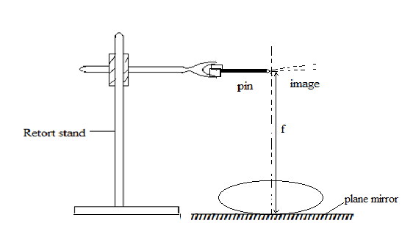
- Adjust the height of pin until a position is found where the pin coincides with its image.
- Measure and record the distance f, of the pin above the plane mirror.
- Displace the pin from the position of coincidence and repeat the procedure in c) to d) to obtain three more values of f. tabulate your results.
- Find the mean position f_{m}of f.

EXPERIMENT 24
In the experiment you will determine the refractive index of a small quantity of a liquid X.
- Place the converging mirror on the bench.
- Clamp an optical pin, horizontally in a retort stand, such that its pointed end lies along the axis of the mirror.
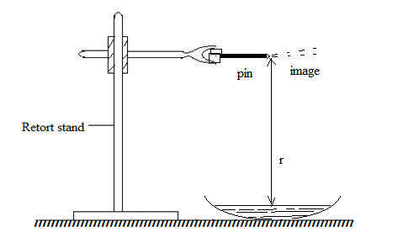
- Adjust the height of the pin above the pole of the mirror until a position is found where the pin coincides with its image. Measure and record distance R of the pin from the pole of the mirror.
- Displace the pin from the position of coincidence and repeat the procedure in C) to obtain three more values of R. tabulate your results.
- Pour a small quantity of the liquid on to the mirror.
- Adjust the height of the pin above the pole of the mirror until a position is found where the pin coincides with its image as shown below.
- . Measure and record distance r of the pin above the liquid.
- Displace the pin from the position of coincidence and repeat the procedure in g) to obtain three more values of r. tabulate your results.
- Calculate the refractive index of the liquid from;
n =$\frac{R_{m}}{r_{m}}$ where $R_{m}andr_{m}$ are mean values of R and r respectively

EXPERIMENT 25
In the experiment you will determine the refractive index, n of a liquid,X using a convex lens and a plane mirror.
- Place the plane mirror provided flat on the bench.
- Place the converging lens on the plane mirror.
- Clamp an optical pin horizontally in a retort stand such that its pointed end lies along the principal axis of the lens as shown in the diagram.
- Adjust the height of pin until a position is found where the pin coincides with its image.
- Measure and record the distance f, of the pin above the plane mirror.
- Remove the lens and place a small quantity of liquid provided on the plane mirror. Place the lens on the top of the liquid.
- Adjust the height of pin until a position is found where the pin coincides with its image.
- Measure and record the distance F, of the pin above the plane mirror
- Calculate the refractive index of the liquid from the expression;
n = 2 – $\frac{f}{F}$

EXPERIMENT 26
In the experiment you will determine the focal length f , of the of the converging lens provided by two methods.
METHOD I
- Connect the dry cell, switch K and the bulb as shown below.
- With a plane mirror fixed on the lens holder with cello tape, place a lens in front of the mirror and arrange the apparatus as below.
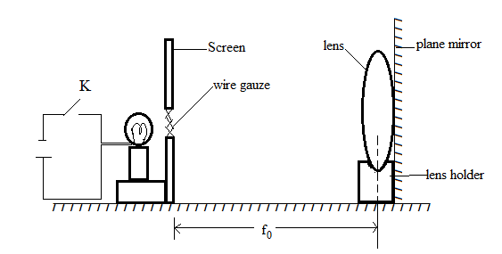
- With switch K closed, adjust the screen until a sharp image of the gauze wire is formed.
- Measure distance, f₀.

METHOD II
- Set the arrangement of the apparatus without a plane mirror as shown below.

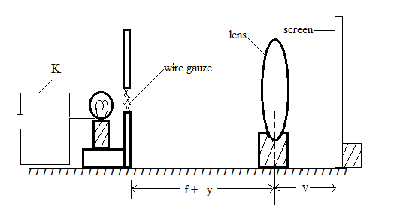

- Adjust the position of the wire gauze to a distance y where y = (f₀ + 2.5)cm.
- Adjust the position of the screen until a sharp image of the wire gauze is formed on the screen. Measure and record the distance, V.
- Obtain the value of x from x = (V- f₀).
- Repeat procedures from b) to d) for values of y = 5.0, 7.5, 10.0, 12.5and 15.0cm.
- Enter your values in the table including values of $\log{x}$ and logy.
- Plot a graph of log x ( vertical axis) against log y (horizontal axis)
- Read and record the intercept C₁ on the log x axis and C₂ on the log y axis hence find their average value C.
- Determine the focal length, f , from the expression; 2logf = C.

EXPERIMENT 27
In the experiment you will determine the focal length f , of the of the converging lens provided by two methods.
METHOD I
- Place a plane mirror on a bench.
- Place the converging lens, L provided on top of the plane mirror.
- Clamp an optical pin P in a retort stand such that its tip lies along the axis of the lens as shown below.
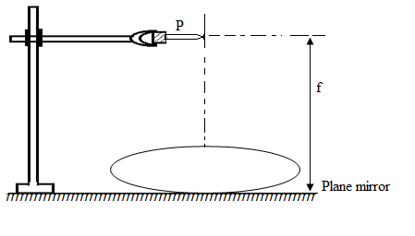
- Adjust the height of the pin to locate the position in which it coincides with its image.
- Measure the distance, f of the pin from the plane mirror.

METHOD II
- Connect the bulb, dry cell and the switch K in series.
- Arrange the apparatus shown in the diagram below
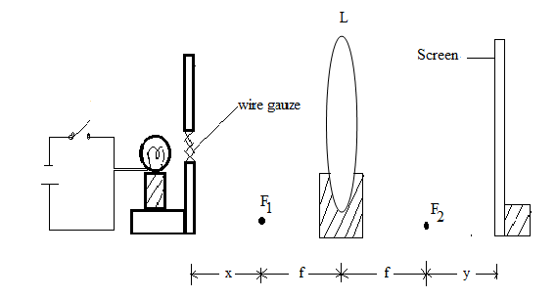

- Adjust the position of the wire gauze to a distance x =2.5cm from the focal point F₁ of lens
- Adjust the position of the screen until a sharp image is obtained on the screen.
- Measure and record the distance, y of the screen from a focal point F₂ of L.
- Repeat the procedure from c) to e) for values of x= 5.0, 7.5, 10.0 12.5 and 15.0cm.
- Enter your results in a table including values of $\frac{1}{X}$.
- Plot a graph of y against $\frac{1}{X}$.
- Find the slope, S of your graph.
- Calculate the focal length of the lens from f =$\sqrt{S}$

EXPERIMENT 28
In this experiment you will determine the refractive index of a glass slab.
- Measure and record the thickness, t, of the glass slab provided
- Fix the plane sheet of paper provided on the drawing board
- Place the slab on the sheet of paper as shown below
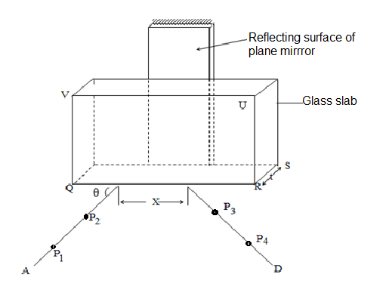
- Trace the outline QRST of the slab
- Remove the slab
- Draw a line AB making an angle θ = 20º with QR at B. Stick pins P₁ and P₂ on AB as shown
- Replace the slab and place a plane mirror just behind it as shown in the figure.
- While looking through the face QRUV of the slab, stick pins P₃ and P₄ in the line with images of P₁ and P₂ as seen through the slab and the mirror.
- Remove the slab and the mirror
- Draw a line DC through P₃ and P₄
- Measure and record the distance x.
- Repeat procedures (f) to (k) for values of Θ = 30º, 40º, 50º, 60º, and 70º
- record your results in a suitable table including columns for x²
and y² = x² + 4t² cos²Θ

- plot a graph of y² against x²
cos²Θ

- Find the slope S of your graph
- Calculate the refractive index n of the slab from n² = S.

EXPERIMENT 29
In the experiment, you will determine the refractive index n of the glass block provided.
Method I:
- Set up the illuminated object O, in front of the mirror, Z as shown below:
Adjust the mirror until a sharp image appears on the screen beside the object.
- Measure and record distance p.

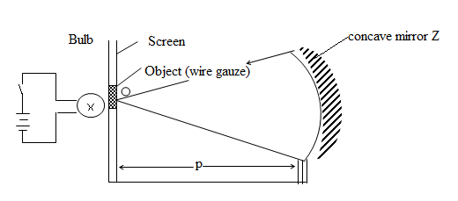
- Place the glass block provided between O and Z such that the width W faces you as shown in figure below:
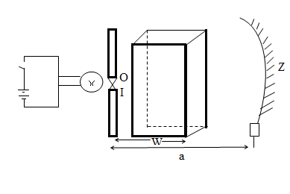
- Adjust the position of the mirror until a sharp image appears beside O.
- Measure and record the distance a between O and Z and the width, W of the glass block.
- Calculate the displacement, d of the object from the equation

d = (a – p)
Calculate n₁ from: n₁ = W
(W – d )
Method II:
- Place the white sheet of paper provided on a drawing board
- Place the glass block on the white sheet of paper with the broad face top most.

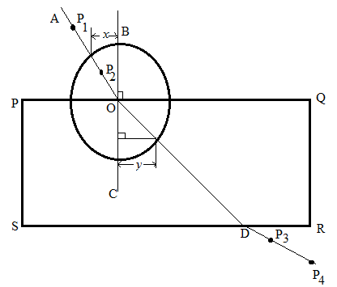

- Trace the outline of the block.
- Remove the glass block and then label the outline PQRS as shown in figure 4.
- Draw a line BC normal to PQ at O, a distance of 2.5 cm from P.
- Draw a line AO making an angle
- Fix pins P₁ and P₂ vertical on AO and replace the glass block on its outline
- Looking through the glass block from side SR, fix pins P3 and P4 such that they appear to be in line with P₁ and P₂
- Remove the glass block and the pins
- Draw a line through P3 and P4 to meet SR at D
- Join O to D
- Repeat procedures (f) to (k) for values of θ = 30º, 40º, 50º, 60º and 70º
- With O as the centre, draw a circle of radius 4cm
- From the intersection of AO and OD with the circle, draw perpendiculars to BC
- Measure and record the perpendicular distances x and y for each value of θ
- Plot a graph of x against y.
- Find the slope n₂ of the graph

EXPERIMENT 30
In this experiment you will determine the refractive index, n, of the glass block provided.
- Measure and record the breadth, b, of the glass block.
- Place the glass block on the plain paper provided with the broad face top most and draw its outline ABCD as shown in figure .

- Draw a normal NS at point O, a distance of 2.0 cm from B.
- Draw a line PO at an angle i =20⁰ to NS.Fix two pins P₁ and P₂ on line PO.
- Replace the glass block on its outline.
- Looking through the glass block from side DC fix pins P₃ and P₄ such that they appear to be in line with the images of P₁ and P₂.
- Remove the glass block and the pins.
- Draw a line through P₃ and P₄ to meet DC at Q.
- Join Q to O. Measure and record angle r.
- Produce line PO to meet DC at T.
- Draw a line from Q to meet TO at right angle.
- Measure and record the distances x₁ and d₁.
- Repeat procedures (d) to (m) for values of i = 30⁰,40⁰,50⁰,60⁰ and 70⁰.

- Tabulate your results including values of sin r and
y₁ = $\frac{d_{1}}{b}+\frac{btanr}{x_{1}}$
- Plot a graph of y₁ against sin r.
- Determine the slope n of the graph.

EXPERIMENT 31
In the experiment you will determine the refractive index, n of the material of a glass block provided.
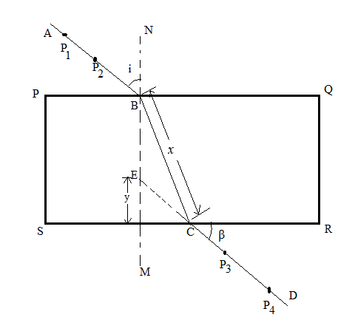
- Fix the plain sheet of paper on a soft board.
- Place the glass block on the plain paper provided with the broad face top most and draw its outline PORS as shown in figure above.
- Draw a normal NM at B about 3cm from P.
- Draw a line AB such that angle i = 10º as shown in the figure above.
- Place back the glass block on its outline.
- Fix pins P₁ and P₂ vertically along AB.
- While looking through the glass block from side SR, fix pins P₃ and P₄ such that they appear to be in line with images of P₁ and P₂.
- Remove the glass block and the pins.
- Draw a line through P₃ and P₄ to meet SR at C and produce DC to meet NM at E.
- Measure and record angle β and distances y and x.
- Repeat procedures d) to j) for values of i = 20º, 30º, 40º, 50º and 60º.
- Record your values in a suitable table including values of sini, tanβ, xtanβ and $\frac{y}{x\tan{β}}$
- . Plot a graph of siniagainst $\frac{y}{x\tan{β}}$.
- Calculate slope, n. of your graph.

EXPERIMENT 32
In the experiment you will determine the refractive index, n of the material of a glass block provided.
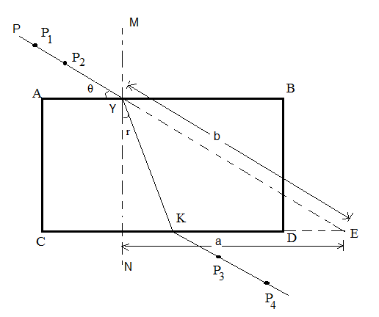

- Fix the plain sheet of paper on a soft board.
- Place the glass block on the plain paper provided with the broad face top most and draw its outline ABCD as shown in figure above.
- Draw a normal MN at Y at y =2cm from A.
- Draw a line PY such that angle θ = 25º as shown in the figure above.
- Place back the glass block on its outline.
- Fix pins P₁ and P₂ vertically along PY.
- While viewing from side CD, fix pins P₃ and P₄ such that they appear to be in line with images of P₁ and P₂.
- Remove the glass block and the pins.
- Draw a line through P₃ and P₄ to meet CD at K and join KY.
- producePYand CD to meet E.
- Measure and record angle r and distances a and b.
- Repeat procedures d) to k) for values of θ = 35º, 45º, 55º, 65º and 75º.
- Record your values in a suitable table including values of sinrand $\frac{a}{b}$.
- Plot a graph of $\frac{a}{b}$ against sinr.
- Calculate slope, n. of your graph.

EXPERIMENT 33
In the experiment you will determine the refractive index, n of the material of a glass block provided.
- Measure and record width, w, of the glass block provided.
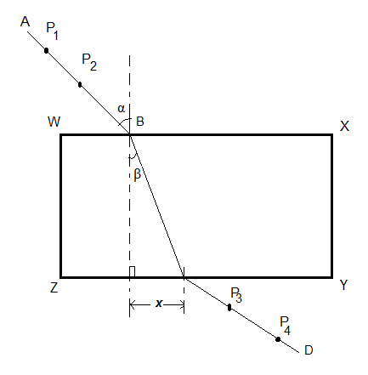
- Fix the plain sheet of paper on a soft board.
- Place the glass block on the plain paper provided with the broad face top most and draw its outline WXYZ as shown in figure above.
- Draw a line perpendicular to WX at B 3cm from W.
- Draw a line AB such that angle α = 5º and replace the glass block on its outline.
- Fix pins P₁ and P₂ vertically along AB.
- While looking through the glass block from side ZY, fix pins P₃ and P₄ such that they appear to be in line with images of P₁ and P₂.
- Remove the glass block and the pins.
- Draw a line through P₃ and P₄ to meet ZY at C. Measure and record angle β and distances x.
- Repeat procedures d) to h) for values of α = 10⁰,15⁰, 20⁰,25⁰ 30⁰, 40⁰, 50⁰ and 60⁰.
- Record your values in a suitable table including values of sinα and xcosβ.
- . Plot a graph of α against β and find the slope, S₁, of the graph where α =10⁰.
- Plot another graph of sinα against xcosβ for values of α = 20⁰, 25⁰, 30⁰, 40⁰, 50⁰ and 60⁰.
- Find the slope, S ₂, of the graph.
- Evaluate n from the expression; 2n = (S₁ + WS₂)

EXPERIMENT 34
In the experiment you will determine the constant β of the glass block provided using two methods.
METHOD 1
- Fix a plain sheet of paper on a soft board using drawing pins.
- Place a glass block with its broad surface on the paper and trace its outline ABCD.
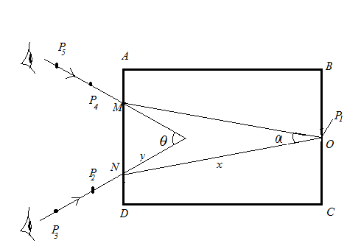

- Remove the glass block from its outline and mark the mid-point O of side BC.
- Replace the glass block on its outline and fix an optical pin P₁, vertically and close to side BC at O.
- While looking through the block from side AD, fix pins P₂ and P₃ such that they appear to be in line with the images of P₁. Mark the positions of P₂ and P₃.
- Remove pins P₂ and P_{3.}
- While looking through side AD again, fix pins P₄ and P₅ such that they are also in line with the images of P1 as shown in the figure above. Mark the positions of the pins P₄ and P₅. Remove pins P₄ and P_{5.}
- Remove the glass block and draw lines throughP₃.P₂ and through P₅, P₄ to their point of intersection, P.
- Join O to M and also O to N.
- Measure and record the angles α and θ.
- Measure and record the distances ON = x and PN = y.
- Calculate the constant β of the glass block from the expression
β =x$\cos\left(\frac{α}{2}\right)$
y$\operatorname{Cos}\left(\frac{θ}{2}\right)$

METHOD II
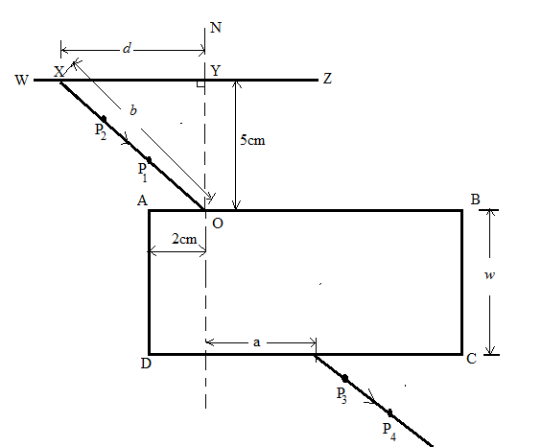
- Measure and record the width W of the glass block.
- Fix a plain sheet of paper on a soft board using drawing pins.
- Place the glass block on the paper with its broad face upper most and trace the outline ABCD.
- Remove the glass block from its outline and draw a normal NM at O such that AO = 2.0cm.
- Draw a normal WZ at Y such that YO = 5.0cm and WY = 10.0cm.
- Draw line XO such that d = 2.0cm where d = XY.
- Replace the glass block on its outline.
- Fix pins P₁ and P₂ along XO.
- While looking through the glass block from side DC, fix pins P₃ and P₄ such that they appear to be in line with the images of pins P₁ and P₂.
- Remove the glass block and the pins.
- Draw a line through P₃ and P₄ to meet side DC at P as shown in the figure above.
- Measure and record distances a and b where b = XO.
- Repeat procedures f) to l) for values of d = 2.5, 3.0, 4.0, 6.0 and 8.0cm.
- Record your results in a suitable table including values of $\frac{1}{a^{2}}$ and $\frac{b^{2}}{d^{2}}$ .
- Plot a graph of $\frac{b^{2}}{d^{2}}$ against $\frac{1}{a^{2}}$ .
- Obtain the slope S of the graph.
- Calculate the constant β of the glass block from the expression,

S =${\left(\frac{W}{β}\right)}^{2}$

EXPERIMENT 35
In the experiment you will determine the refractive index, n, of the material of a glass block provided.
- Measure and record the width, t, of the glass block provided.
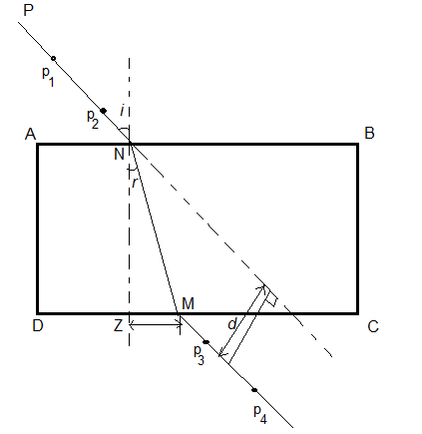
- Fix the plain sheet of paper on a soft board.
- Place the glass block on the plain paper provided with the broad face top most and draw its outline ABCD as shown in figure above.
- Draw a normal line to NZ at 3.0cm from A.
- Draw a line PN such that angle i = 15º as shown in the figure above.
- Place back the glass block on its outline and fix pins P₁ and P₂ vertically along PN.
- While looking through the glass block from side DC trace the path of light using P₃ and P₄.
- Remove the glass block and the pins and draw a line through P₃ and P₄ to meet DC at M.
- Measure and record angles rand the lateral displacement, d.
- Repeat procedures e) to i) for values of i = 20º, 30º, 30⁰,50º and 60º.
- Tabulate your results including values of dcosrand sin(i – r).
- . Plot a graph of dcosr against sin(i – r).
- Calculate slope, S, of your graph and the ratio$\frac{S}{t}$.
- Measure length a =ZM for I =20⁰ and d = ZM for i = 60⁰.
- Calculate n from the expression n² = $\frac{S^{2}}{θ}$ where θ = $\frac{{(b}^{2}-a^{2})}{ab}$.

EXPERIMENT 36
In the experiment you will determine the focal length, F and external diameter of a cylindrical glass vessel containing water and acting as cylindrical lens.
- Set up the arrangement as shown below with the filament lamp vertically above the zero mark of the meter rule.

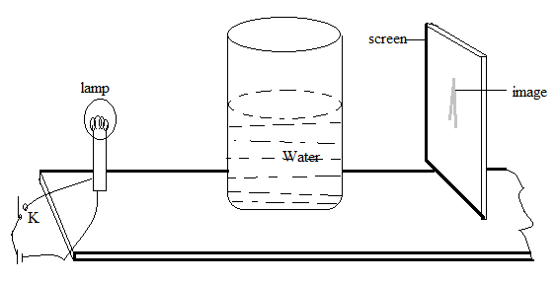
- Place a screen at a distance x = 45cm from the lamp.
- Adjust the lens (towards the lamp and also towards the screen) to find two positions of the lens which will give vertical bright vertical image on the screen.
- Find the distance y between these two positions of the lens.
- Repeat procedure b) to d) for other values of x . the range of x should be from a little more than four times the diameter of a lens up to 60cm.
- Tabulate your results
- Plot a graph of y against x with y scale starting from 0 and x scale from 20cm.
- Find the value of x₁ where the value of y is half the value of x from your graph and record it.
- Calculate f from the formula f₁ =$\frac{x_{1}}{16}$.
- From your graph find the value of x₂ on the x -axis where y is four times the value of x and record it.
- Calculate f₂ from f₂ = 0.2x_{2.}
- Find the average value F of the above two values of f.
- Measure the average external diameter d of the cylindrical vessel hence find the ratio of$\frac{d}{F}$.

EXPERIMENT 37
In the experiment you will determine the refractive index, n, of a triangular prism.
- Fix the sheet of paper provided on a soft board using drawing pins.
- Place the glass prism on the white sheet of paper and trace the outline WXY as shown the figure below.
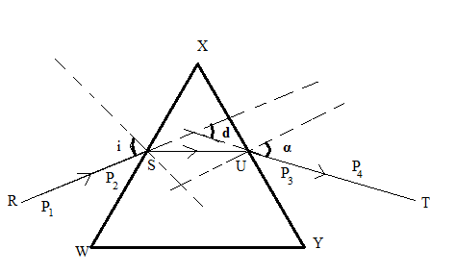
- Draw a normal N along WX and a line RS such that i = 30⁰.
- Fix the pins P₁ and P₂ vertically on RS..
- While looking through a prism from side XY. Fix pins P₃ and P₄ such that they appear in line with the imagesof P₁ and P₂.
- Remove the prism and the pins and draw a line TU through the marked positions of P₃ and P₄and thenormal XY at T. Measure and record the angle α between the normal and TU.
- Produce RS and TU such that they meet, measure and record angle d.
- Repeat the procedures c) to g) for values of angles of incidence, i = 35⁰, 40º, 50º, 60º and 65º.
- Tabulate your values in a suitable table including values of (d- α).
- Plot a graph of (d- α) against i.
- Read and record the intercept A on the i axis.
- On the same axes, plot a graph α verses i. Read and record α₀ andi_{o}the coordinates of the point of intersection of the two graphs.
- Calculate D₀ from D_{O} = (α₀+ i_{o}–A)
- Obtain the refractive index of the glass prism using the equation.
n = $\frac{\sin{\frac{1}{2}}\left(D_{0}+ A\right)}{\sin{\frac{1}{2}}A}$

EXPERIMENT 38
In the experiment you will determine the refractive index, n, of a triangular prism.
- Fix the sheet of paper provided on a soft board using drawing pins.
- Place the glass prism on the white sheet of paper and trace the outline ABC as shown the figure below.
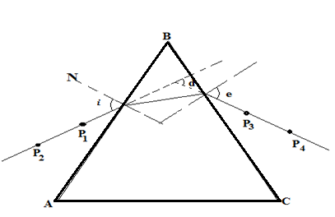

- Draw a normal N along AB.
- Fix the pins P₁ and P₂ such that they angle of incidence is equal to 30⁰.
- Observe pins P₁ and P₂ through face AC. Fix pins P₃ and P₄such that they appear in line with P₁ and P₂.
- Remove the prism and the pins and trace the trace the ray through the prism.
- Measure and record the angle of deviation, d, and the angle of emergence, e.
- Repeat the procedures d) to g) for values of angles of incidence equal to 40º, 50º, 60º, 65º and 70º.
- Tabulate your values in a suitable table including values of (d-e).
- Plot a graph of d against i and use it to determine the angle of minimum deviation m.
- Plot a graph of (d-e) against i and the read the intercept C on the i-axis.
- Calculate the refractive index of the glass prism using the equation.
n= $\frac{\sin{\frac{1}{2}}\left(m+c\right)}{\sin{\frac{1}{2}}c}$

EXPERIMENT 39
In the experiment you will determine the refractive index, n, of the material of the glass.
- Fix the sheet of paper provided on a soft board using drawing pins.
- Place the glass prism on the white sheet of paper with its triangular section facing upwards and trace the outline as shown the figure below.
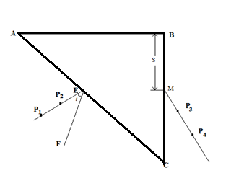

- Remove the glass prism.
- Measure and record the length, d of AB in cm.
- Mark a point E on AC a distance 1.0cm from A.
- Draw a line a EF perpendicular to AC.
- Draw a line EG making angle, i = 15o to EF.
- Fix pin P₁ and P₂ on EG.
- Replace the glass prism on its outline.
- Looking through the face BC of the prism, fix two pins P₃ and P₄ so that they appear to be in the same line with the images P₁ and P₂.
- Remove the glass prism.
- Draw a line through P₃ and P₄ to meet the line BC at M.
- Measure the length, S of BM in cm.
- Repeat the procedures h) to n) for values of i = 20º, 25º, 30º and 40º.
- Enter the results in a suitable table including values of sin^{s} i and Y where
Y =$\frac{{\left(S-t\right)}^{2}}{m^{2}+ {(s\sqrt{2 }+ 1)}^{2}}$ where t = $\left(d-\sqrt{2}\right)$ and m = ${(d\sqrt{2})}^{-1}$
- Plot a graph of sin²i against Y.
- Find the slope, P from the graph.
- Calculate the refractive index, n of the material of the prism from the equation
n = $\sqrt{P}$

EXPERIMENT 40
In the experiment, you will determine the refractive index ,n of the glass of a prism
- Place a half meter rule on a bench with its graduated face upwards in that the zero end overlaps the bench as shown below.
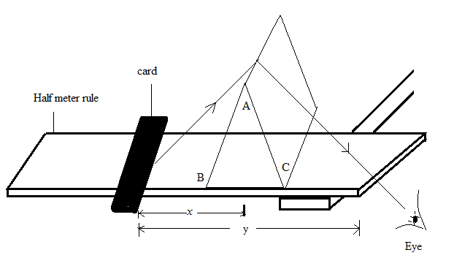
- Place a piece of red card at far side of the eye.
- Looking through the tip of the prism and the zero end , move the card until its edge is only just visible in the tip of the prism.
- Read and record distances y and x .
- By varying x from a bout 20cm to about 5cm obtain a set of values of y and x.
- Enter your values in a suitable table.
- Plot a graph of y against x.
- Use your graph to find the minimum value y₀ of y.
- Calculate the angle of minimum deviation 2θ where tanθ = $\frac{2h}{y0}$ and h is the height of the tip of the prism from the half meter rule.
- Measure angle A of the prism.
- Calculate n from n = $2\sin{\frac{1}{2}}( A+2θ)$.
- Support the prism on a piece of a block , record the new value of h¹.
- Repeat procedures b) to f).
- On the same graph paper using the same axes as before, plot a graph of y against x.
- Use your graph to find the minimum value $y_{0}^{1}$ of y.
- Calculate the angle of minimum deviation 2θ where tanθ¹ = $\frac{2h^{1}}{y_{0}^{1}}$ .
- Calculate the refractive index n¹ from n¹=$2\sin{\frac{1}{2}}( A+2θ^{1})$.

CURREN ELECTRICITY
The following are some of the circuit symbols.
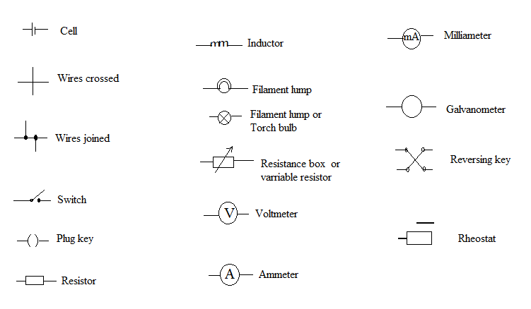

EXPERIMENT 41
In the experiment you will determine
- The resistance per unit length of a given wire
- The internal resistance of a dry cell
PART 1
- Connect the circuit as shown in the diagram below
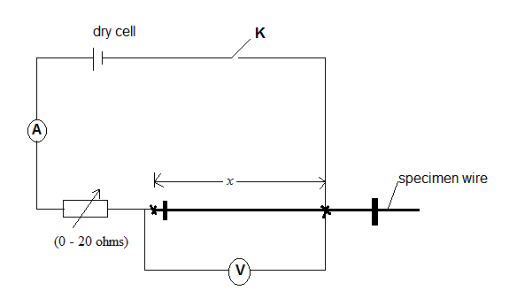
- Starting with distance x = 20.0cm, adjust the rheostat to its maximum with K open.
- Close switch K and adjust the rheostat until the ammeter reading is I is 0.4A.
- Read and record the ammeter voltmeter reading V.
- open switch K.
- repeat procedures b) toe) for values of x = 30.0, 04.0, 50.0, 60.0, 70.0, 80.0 and 90.0cm
- enter your results in a suitable table including values of $\frac{V}{I}$.
- Plot a graph of $\frac{V}{I}$ against x .
- Determine the slope S₁.

PART 11
- Connect the circuit as shown below.
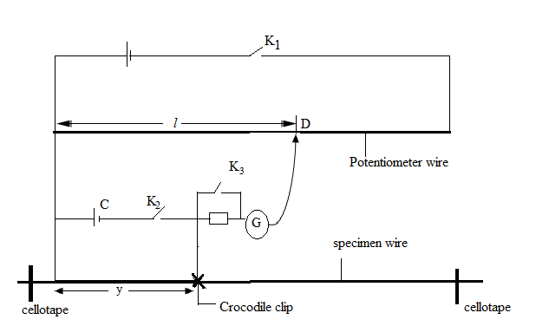
- Starting with y = 0.200m, close switches K₁ and K₂.
- Move the sliding contact along the potentiometer wire until a balance point is obtained where the galvanometer shows no deflection. Measure and record length l.
- Close K₃ to locate the balance point accurately.
- Open switchesK_{3,} K₁ and K₂.
- Repeat procedures b) to e) for values of y = 0.300, 0.400, 0.500 and 0.600m.
- Enter tour results in a suitable table including values of $\frac{1}{y} and\frac{1}{l}$.
- Plot a graph of $\frac{1}{y} against \frac{1}{l}$.
- Find the slope S₂ and the intercept C on the $\frac{1}{l}$ axis on the graph.
- Calculate r from, r = $\frac{S_{1}}{{CS}_{2}}$.

EXPERIMENT 42
In this experiment you will determine the resistance per metre of the potentiometer wire
PART 1
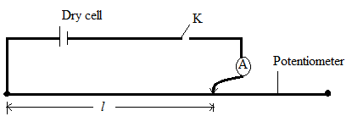
- Connect the circuit shown in fig 3, with length ⎩ = 0.0500m
- Close switch K, and record the reading I of the ammeter.
- Calculate the resistance per metre r from the equation r = $\frac{1.5}{lI}$
PART II
In this experiment you will determine the potential difference per metre V, across a potentiometer wire
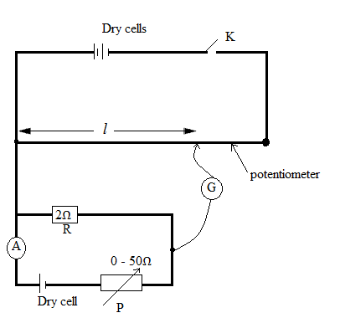

- Connect the circuit shown above
- Adjust P so that the ammeter indicates a reading I = 0.02A
- Close switch K
- Move the sliding contact along the potentiometer wire until a point is found where the galvanometer G shows no deflection
- Record in metres, the balance length l .Open switch K
- Repeat procedures (b) to (e) for I = 0.04, 0.06, 0.08, 0.10, and 0.12 A
- Tabulate your results.
- Plot a graph of lagainst I and determine the slopes of the graph.
- Find the value of V from the expression V = $\frac{R}{S}$

EXPERIMENT 43
In the experiment you will determine the current through a bulb at a given p.d
- Connect the circuit as shown below
- With switch K closed, adjust the rheostat to obtain a smallest reading of V₀ of the p.d across R(5Ω) and record it.
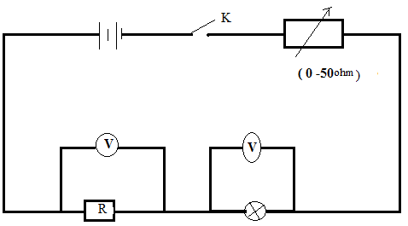
- Measure and record the p.d V across the bulb.
- Adjust the rheostat to obtain 8 higher values of V₀ and the corresponding values of V.
- Enter your results in a suitable table.
- Plot a graph of V against V₀.
- determine the values of V when the resistance of the bulb is 5Ω.
- Calculate the current through the bulb when R = 5Ω.

EXPERIMENT 44
In the experiment you will determine the resistance per meter, p of the wire provided and the internal resistance, r of cell C.
PART I
- Connect the circuit as shown
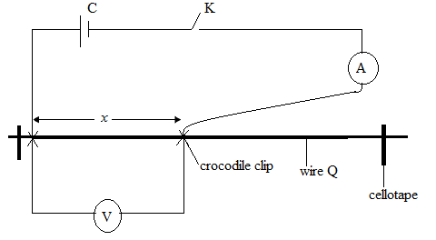
- Adjust the position of the jockey such that x = 0.500m.
- Close switch K.
- Read and record the voltmeter reading V₁ and the ammeter reading I₁.
- Repeat procedure b) to c) for x = 0.750m.
- Read and record the voltmeter reading V₂ and the ammeter reading I₂.
- Calculate the resistance per meter, P of the wire from the expression:
P = $\left[\frac{V_{1}}{I_{1}} +\frac{{2V}_{2}}{3I_{2}}\right]$

PART II
- Connect the circuit shown below
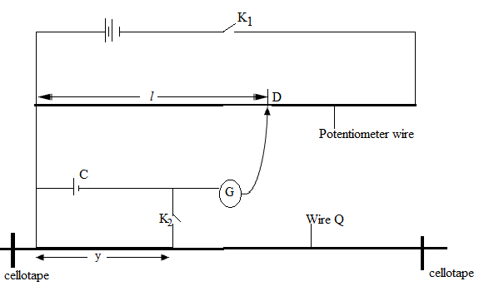
- Starting with y = 0.200m, close switch K₁ and K₂.
- Move the sliding contact along the potentiometer wire to a point d where the galvanometer shows no deflection.
- Measure and record the length l in meters.
- Open switches K₁ and K₂.
- Repeat procedures b) to c) for y = 0.300, 0.400, 0.500, 0.600, 0.700 and 0.800m.
- Enter your results in a suitable table including values of $\frac{1}{y} and \frac{1}{l} .$
- Plot a graph of $\frac{1}{y} against \frac{1}{l} .$
- Find the slope, S and intercept C on the $\frac{1}{l} axis.$
- Calculate the internal resistance, r of the cell C from; r = $\frac{SP}{C}$

EXPERIMENT 45
In the experiment, you will determine the resistivity of the wire labeled P Using two methods.
PART 1
- Connect the circuit as shown below. Starting with length l = 0.100m. complete the circuit while keeping switch K open. Read and record V₀.
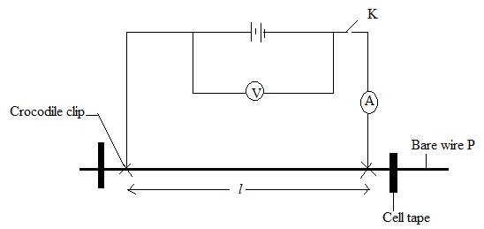
- Close switch K.
- Read and record the ammeter reading I.
- Open switch K.
- Repeat procedures c) to d) for values of l = 0.200, 0.300, 0.400, 0.500, 0.600, 0.700, 0.800 and 0.900m
- Enter your results in a suitable table including values of $\frac{1}{I}$.
- Plot a graph of $\frac{1}{I}$against l.
- Determine the slope S₁ of your graph.
- Determine the mean diameter, d of the bare wire.
- Find the value of P from, P = $\frac{πS_{1}d^{2}V_{0}}{4}$

PART 11
- Connect the circuit as shown below
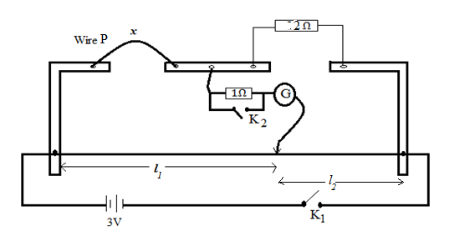
- Starting with x = 0.100m, close switch K₁.
- Move the sliding contact along the meter bridge wire to the D where the galvanometer shows no deflection.
- Close switch K2.Measure and record the balance lengths l₁ andl₂.
- Repeat procedures d) to d) for values of l = 0.200, 0.300, 0.400, 0.500, 0.600, 0.700 and 0.800m.
- Enter your results including values of R = $\frac{2l_{1}}{l_{2}}$into a suitable table.
- Plot a graph of R against x .
- Find the slope S₂ of your graph.
- Find the value of P₂from P₂ = $\frac{πS_{2}d^{2}}{4}$where d is the diameter determined in partone.

EXPERIMENT 46
In the experiment, you will determine the resistivity, ρ of the material of a wire Q given by two methods.
METHOD1
- Connect the dry cells, ammeter A and wire Q as shown in the circuit in the figure below 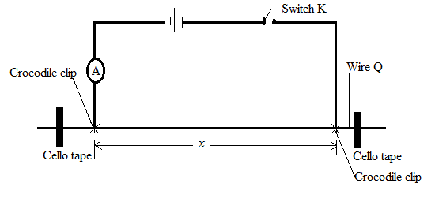
- Starting with, x =x₁= 20.0cm, record the reading i₁ on the ammeter when K is closed.
- Open switch K.
- Adjust x = x₂ = 70.0cm, read and record reading i₂ on the ammeter when K is closed.
- Determine ρ₁from ρ₁=1.6 x10⁻⁷ф where ф = $\frac{100(i_{1}- i_{2})}{i_{1}i_{2}(x_{2}-x_{1})}$ , where x₁ and x₂ are in cm.
METHOD II
- Connect the meter bridge circuit shown in the figure below.
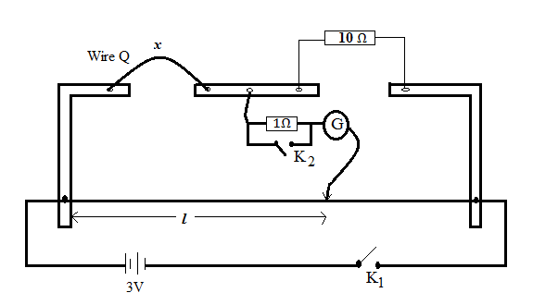

- Close switch K_{1.}Starting with x = 20.0cm, find the balance length.
- Close switch K₂ and determine accurately the balance length, l.
- Repeat procedures c) to d) for values of x = 30.0, 40.0, 50.0, 60.0, 70.0 and 80.0cm.
- Tabulate your results including values of $\frac{1}{l} and\frac{1}{x}$ in your table of results.
- Plot a graph of $\frac{1}{x}$ against $\frac{1}{l}.and$find the slope, S of your graph.

EXPERIMENT 47
In the experiment you will determine the internal resistance r of the dry cell, C provided using two methods.
PART 1
- Connect the circuit as shown in the figure below.
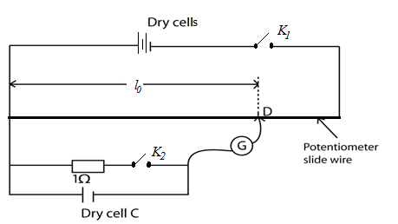
- Close switch K₁ and move the sliding contact along the potentiometer wire until a point, D is found where the galvanometer G shows no deflection.
- Read and record the balance length, l₀ in meters.
- close switch K₂ and move the sliding contact along the potentiometer wire until a point, D is found where the galvanometer G shows no deflection.
- Read and record the balance length, l in meters.
- Calculate the internal resistance r₁ of the cell, C from the expression: r₁ = $\frac{l_{0}- 1}{l}$

PART II
- Connect the circuit as shown in the figure below.
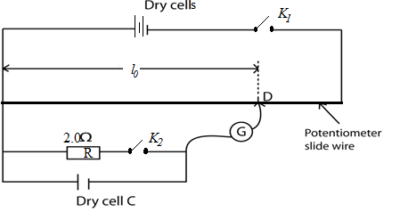
- Starting with R = 2.0Ω, close both switches K₁ and K₂.
- Move the jockey along the potentiometer wire until a point where the galvanometer shows no deflection is found.
- Read and record the balance length l, in meters.
- Repeat procedures b) to d) for values of R= 3.0, 4.0, 5.0, 7.0 and 10.00Ω.
- Tabulate your result including values of $\frac{1}{R}$and $\frac{1}{l}$.
- Plot a graph of $\frac{1}{l}$against$\frac{1}{R}.$
- Find the slope, S of the graph.
- Calculate the internal resistance r2 from the expression r2 = Sl₀.
- Calculate the internal resistance of the cell, C from r = $\frac{r_{1}+r_{2}}{2}$.

EXPERIMENT 48
In this experiment you will determine the internal resistance r of the dry cell labeled C.
Part I
- Connect the circuit shown in figure 4.

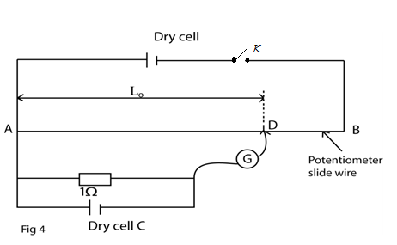
- Close switch K and move the sliding contact along the potentiometer slide wire to a point D where the galvanometer shows no deflection.
- Measure and record the balance length L_{0.}
- Calculate the internal resistance r of the dry cell from the expression:
$$r=\left(\frac{1}{L_{o}}-1\right)$$

Part II
In this experiment you will determine the electrical resistivity ρ of the material of the bare wire labeled Q.
- Measure and record the diameter, d, of the wire labeled Q.
- Connect the circuit shown in figure 5.

- Starting with y=0.200m close switch K.
- Move the sliding contact along the metre bridge wire to a point D where the galvanometer shows no deflection.
- Measure and record balance lengths L₁ and L₂
- Open switch K.
- Repeat procedures (c) to (f) for values of y=0.300,0.400, 0.500,0.600,0.700, 0.800m
- Tabulate your results including values of $\frac{1}{y}$ and $\frac{L_{2}}{L_{1}}$
- Plot a graph of $\frac{1}{y}$against $\frac{L_{2}}{L_{1}}$.
- Determine the slope R₁ of the graph.
- Calculate the resistivity $ρ$from the expression: $R_{1}=\frac{2ρ}{5πd^{2}}$ where $π=3.14$

EXPERIMENT 49
In the experiment you will determine the resistivity ф of the material of a wire.
- Measure and record the diameter, d, of the wire provided.
- Connect a dry cell, the ammeter A and switch K1 across the wire provided as shown in the figure below.
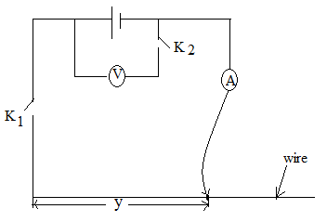s
- Connect a voltmeter and switch K₂ across the dry cell. Close K₂ and record the voltmeter reading V₁.
- Open K₂ .
- Move the sliding contact such that distance y = 30.0cm.
- Close K1 and record the ammeter reading I.
- Open K1.
- Repeat procedures e) to g) for values y = 40.0, 50.0, 60.0, 70.0 and 80.0cm.
- Tabulate your results including values of $\frac{1}{I}$.
- Plot a graph of $\frac{1}{I}$against y.
- Determine the slope S, of the y.
- Calculate the resistivity фof the material of the wire from the expression.
S = $\frac{4ϕ}{{πd}^{2}V_{1}}$

EXPERIMENT 50

In the experiment you will determine a constant k of the resistor marked R_{S}.
- Connect the circuit as shown in the figure below.
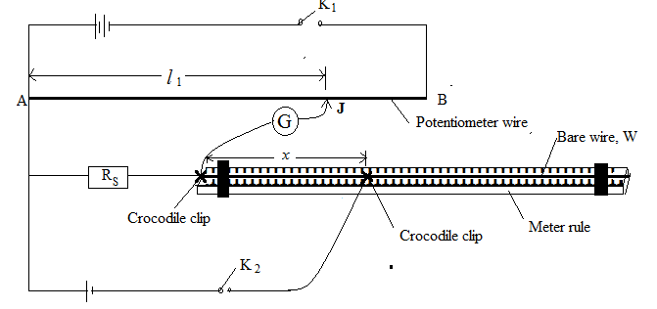
- Adjust the length x to 0.200m.
- Close switches K₁ and K₂.
- Move the sliding contact J along the potentiometer slide wire AB until a point is found where the center G zero galvanometer shows no deflection.
- Read and record the length l₁.
- Open switches K₁ and K₂.
- Repeat procedures b) to f) for values of x = 0.300, 0.400, 0.500, 0.600, 0.700 and 0.800m.
- Dismantle the circuit.

PART 11
- Connect the circuit as shown in the figure below.

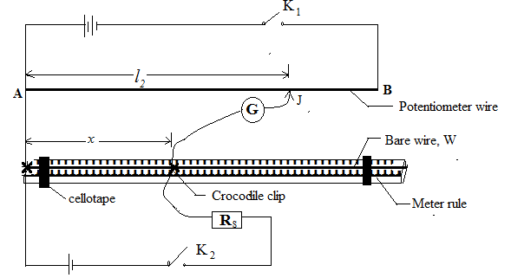

- Adjust the length x to 0.200m.
- Close switches K₁ and K₂.
- Move the sliding contact J along the potentiometer slide wire AB until a point is found where the center G zero galvanometer shows no deflection.
- Measure and record the balance length l₂.
- Open switches K₁ and K₂.
- Repeat procedures j) to n) for values of x = 0.300, 0.400, 0.500, 0.600, 0.700 and 0.800m.
- Record your results in a suitable table including values of $\frac{l_{2}}{l_{1}}$.
- Plot a graph of xagainst $\frac{l_{2}}{l_{1}}$ .
- Obtain the slope S of the graph.
- Find the constant, k of the resistor R_{s} from,

EXPERIMENT 51
In the experiment you will determine the resistivity, ρ, of the material of a wire, Q provided.
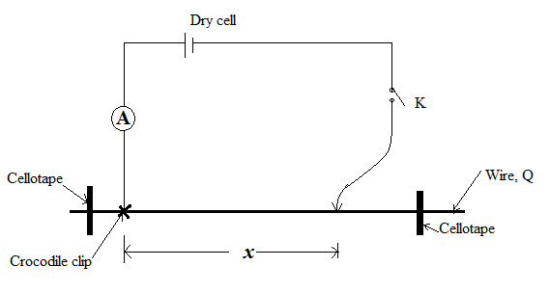
- Connect the circuit as shown in the figure above.
- Starting with x = 0.200m, close switch K.
- Read and record the value of Ifrom the ammeter.
- Repeat procedures b) to c) for values of x = 0.300, 0.400, 0.500, 0.600, 0.700 and 0.800m.
- Record your results in a suitable table including values of$\frac{1}{I}$.
- Plot a graph of $\frac{1}{I}$against x.
- Find the slope, S, of the graph.
- Obtain the resistivity, ρ of the wire from the expression;
ρ = 1.6x 10⁻⁷

EXPERIMENT 52.
In the experiment you will determine the potential difference per meter,
K, of the slide potentiometer wire.
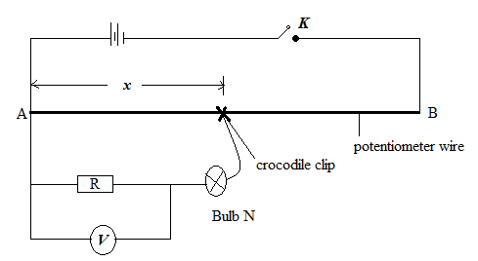
- Record the value of the resistor, R, provided.
- Connect the circuit as shown in the figure above.
- Starting with x = 0.100m, close switch, K. read and record the voltmeter reading, V_{r}.
- Open Switch, K.
- Disconnect the voltmeter and connect parallel to the bulb, N.
- Close Switch, K, read and record the voltmeter reading, V_{n}.
- Repeat procedures b) to f) for values of x = 0.200, 0.300, 0.400, 0.500, 0.600, 0.700 and 0.800m.
- Enter your results in a suitable table.
- Plot a graph of V_{n} against V_{r}.
- Locate the point, V₀ on the graph for V_{n} = V_{r}.
- Plot a graph of V_{n} against x.
- From your graph find value of x = x₀ for which V_{n} = V_{r} is V₀.
- Calculate the potential difference per meter K, of the slide potentiometer wire from the expression:
_{K =} $\frac{V_{0}}{X_{0}}$

EXPERIMENT 53
In the experiment you will determine the
- Resistivity of the bare wire, w
- Resistance of a resister, Q
PART 1
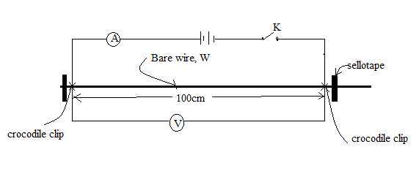
- Connect the circuit as shown in the figure above
- Close switch K.
- Read and record the ammeter and voltmeter readings I and v respectively.
- Calculate r₁, from r₁ =$\frac{V}{I}$

PART II
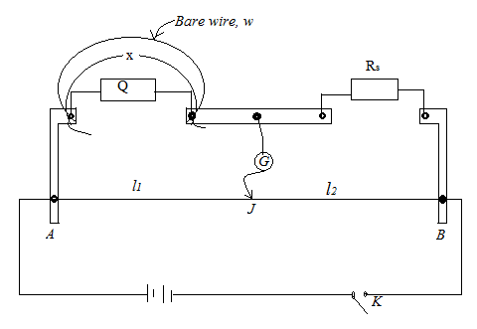
- Connect the circuit shown in figure above with resister Q and bare wire W in parallel across the left hand gap of the meter bridge.
- Connect the standard resistor, R_{s}, in the right hand gap of the meter bridge.
- Adjust the length x, of the bare wire to 3.00m.
- Close switch ,K.
- Move the sliding contact, J along the meter bridge wire AB to locate the balance point for which the galvanometer G, shows no deflection.
- Open switch, K.
- Read and record the balance length,l₁ andl₂.
- Repeat procedures c) to g) for values of x = 0.400, 0.500, 0.600, 0.700 and 0.800m.
- Tabulate your results including values of$\frac{l_{2}}{l_{1}}$and$\frac{1}{x}$.
- plot a graph of $\frac{l_{2}}{l_{1}}$against$\frac{1}{x}$.
- Determine the slope, S of the graph.
- Calculate the resistance per meter, r₂ of the wire, W from the expression.
S =$\frac{R_{S}}{r_{2}}$
- Measure the diameter, d, of the wire W.
- Calculate the resistivity, ρ of the wire, W from the expression.
Ρ =$\frac{{πr}_{2}d^{2}}{4}$

EXPERIMENT 54
In this experiment you will determine the
- Resistance per meter, k, of the wire labeled Q.
- Internal resistance, r, if the dry cell labeled C.
PART 1
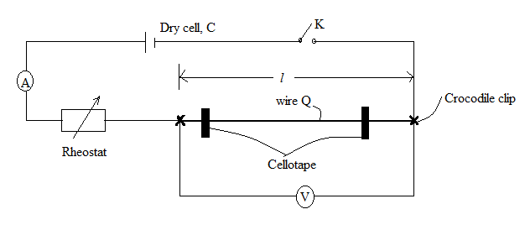

- Connect the circuit as shown in the figure above with distance l = 1.00m.
- Close switch K₁ and adjust the rheostat so that the ammeter indicates I₁ = 0.06A
- Read and record the voltmeter reading V₁.
- Calculate K₁ from the expression
K₁ =$\frac{V_{1}}{I_{1}l}$

- Repeat the procedure b) for I₂ = 0.08A, read and record the voltmeter reading V₂.
K₂ =$\frac{V_{2}}{I_{2}l}$

- Calculate k from the expression:
k = $\frac{K_{1 }+ K_{2}}{2}$

PART II
- Connect the circuit as shown in the diagram below.

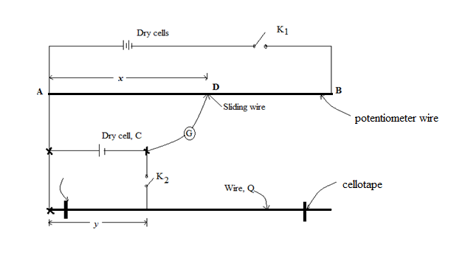
- With K₂ open and K₁ closed , find the balance length l₀ using the sliding contact.
- Open switch K₁.
- Adjust the distance y to 0300m, close switches K₁ and K₂.
- Determine the balance length l.
- Open switches K₁ and K₂
- Repeat procedures d) to f) for values of y = 0.400, 0.500, 0.600, 0.700 and 0.800m.
- Enter your results in a suitable table including values of $\frac{1}{l} and\frac{1}{y}.$
- Plot a graph of $\frac{1}{l} against\frac{1}{y}.$
- Calculate the slope, S of the graph.
- Calculate the internal resistance, r of a dry cell C1 from the expression;
S = $\frac{r}{{Kl}_{0}}$

EXPERIMENT 55
In the experiment you will check the calibration of the voltmeter using a slide wire potentiometer
- Connect the voltmeter provided a cross the terminals of the cell marked S.
- Record the readings for V₀ of the voltmeter.
- Connect the two dry cell connected in series and mark D, in series with a switch k₁ and the potentiometer slide wire, AB.
- Connect cell S in series with the protective resistor P and the center zerogalvanometer G as shown below.
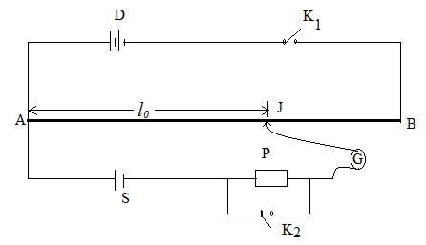
- Close the switch K₁
- Move the slide contact J along the wire to locate a point on AB for which G shows no deflection(balance point)
- Close switch K₂ and locate the balance point accurately.
- Measure and record the balance length L_{0.}
- Open K₁ and K₂.
- Connect the circuit shown below.
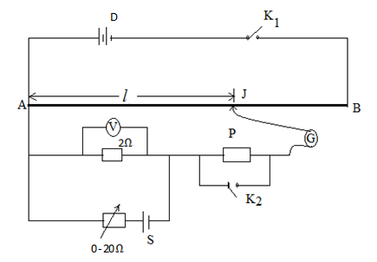
- Close switch K₁.
- Adjust the rheostat until the voltmeter read V_{r}=0.10v.
- Move the sliding connect J a long AB to locate the approximate balance point.
- Close switch K₂ and locate the balance point more accurately.
- Measure the balance lengthl.
- Open switch K2.
- Repeat the procedures e) to (p)for voltmeter reading of 0.20, 0.30, 0.40,0.50,and 0.60
- Tabulate your results including values of V_{a} = $\left(\frac{V_{0}}{l}\right)l_{0}$
- Plot a graph of V_{a} against V_{r}.
- Determine the slope of your graph.
- Comment on the value of slope

EXPERIMENT 56
In this experiment, you will compare the electrical resistance per until length of two wires.
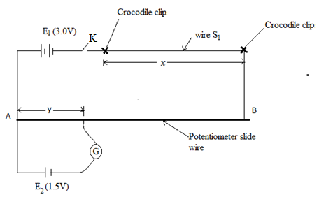
- Connect a length x=5.0cm of the wire labeled S₁, in series with E1 and switch K, cross the potentiometer slide wire AB.
- Connect the cell E₂ in series with a centre zero galvanometer G and sliding contact as shown in the figure above.
- Close switch K.
- Move this sliding connect J along AB to locate a point on AB for which G shown on defection.
- Measure the balance length, y
- Open switch K.
- Repeat the procedure (a)to(f) for value of x=10.0, 15.0,20.0,and 25.0cm.
- Tabulate your results
- Plot a graph of x against y.
- Find the slop, m₁ of the graph.
- Replace the wire labeled S₁ by the one labeled S_{2.}
- Repeat the procedures (a) to (f).
- Tabulate your results.
- Plot, using the same axes as in (i) a graph of x against y.
- Find the slope of m₂ of the graph.
- Calculate the ratio$\frac{m2}{m1}$

EXPERIMENT 57
In the experiment, you will determine the resistanceof labeled Rx, and the internal resistance, r of the cell P, provided
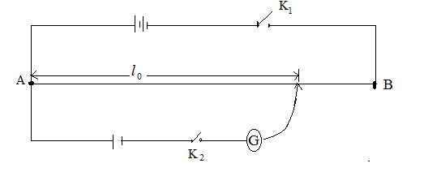

- Connect up the circuit as shown above
- Close the switches K1 and K2 and locate the position D on wire AB for which the galvanometer shows zero deflection.
- Read and record the balance length l_{o.}
- Open the switches K₁ and K_{2.}
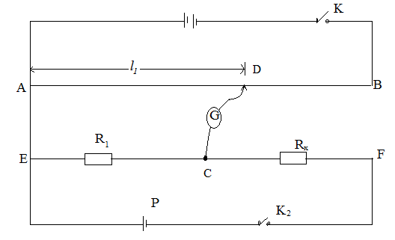
- Connect the circuit as shown in the figure above.
- Close switches K1 and K2.
- Locate the balance point D on the wire AB.
- Record the new balance length l₁s
- Open switches K₁ and K_{2.}
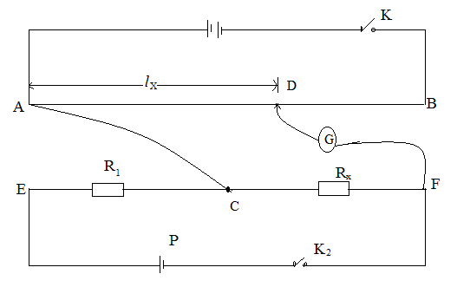

- Remove the connection AE at E and connect AC at C. Disconnect the galvanometer G from C and connect it to F as shown in the figure above.
- Repeat the procedures (b) to (c) and record the balance length l_{x.}
- Locate the balance point D on wire AB.
- Record the balance length l_{x}
- Calculate R_{x} from the expression:
R_{x} = $\frac{lx}{l1}$xR₁
PART II
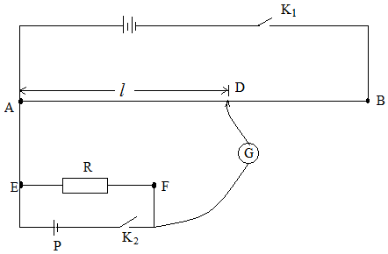
- Disconnect the circuit in part 1.
- Connect the circuit as shown in the figure above with resistor, R = 2Ω.
- Close switches K₁ and K₂.Locate the balance point D along wire AB.
- Repeat procedures b) to f) for R =3, 4, 5, 6, 8 and 10Ω.
- Record your results in a suitable table including values of $\frac{1}{l}$ and $\frac{1}{R}$
- Plot a graph of $\frac{1}{l}$ against $\frac{1}{R}$ and find the slope, S of the graph.
- Determine r from the expression: r = Sl₀

EXPERIMENT 58
In the experiment you will determine the potential difference per meter of a potentiometer wire.

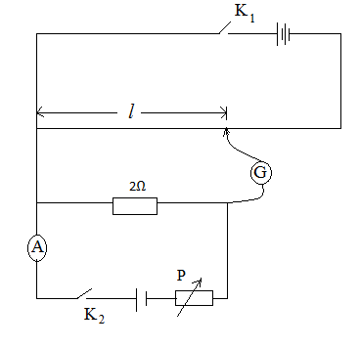

- Connect the circuit as shown in the above figure
- Adjust P so that the ammeter indicates reading I=0.02A.
- Close the switches K1and K2
- Move the sliding connects along the potential meter wire until a point is found where the galvanometer as shown above on deflection.
- Record the balance length l in meters.
- Repeat procedures (b) to (e) for value of I=0.04, 0.06, 0.08, 0.10 and 0.12.
- Tabulate your results.
- Plot a graph of the l and i
- Determine the slope S of the graph.
- Calculate the value of V from the expression
V=$\frac{R}{S}$where R=2

EXPERIMENT 59
In the experiment , you will determine the potential difference per until length σ, of the wire labeled P, by two methods
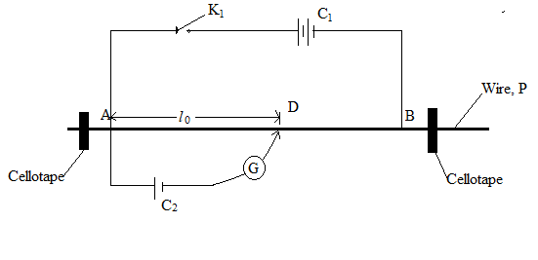
- Connect the circuit shown in the figure above
- Close switch,K
- Adjust the position of the sliding contact, D, until the galvanometer shows no deflection.
- Measure and record the balance length l_{o} in meter
- Open switch , K1
- Calculate, from:

σ =$\frac{1.5}{l_{0}}$
- Disconnect cell C₂ from the circuit.

METHOD II
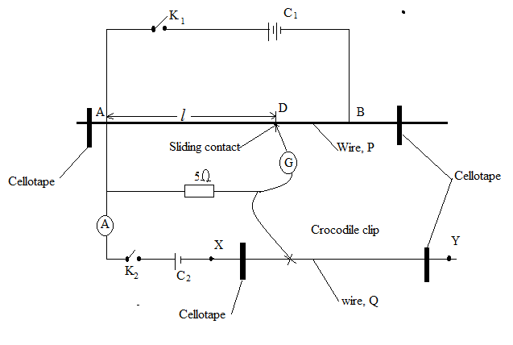

- Connect the circuit shown in the above figure such that AB= 1.00m
- Close switch, K2 keeping switch, K open.
- Adjust the position on the crocodile clip a long wire XY until the reading on the ammeter I= 0.08A
- Close the switch K1, keeping K2 closed and adjust the position of the sliding contact, D along wire AB until the galvanometer shows no deflection.
- Measure and record the balance length, l, in metres
- Open the switch K1 and K2
- Repeat the procedures (b) to (f) for I=0.10, 0.12, 0.14, 0.16, and 0.18A
- Tabulate your result
- Plot the graph of l against i
- Determine the slope S of your graph.
- Calculate the value of σ, from
σ =5S

EXPERIMENT 60
In this experiment you will determine the resistance per metre of a wire using two methods
- Method 1: 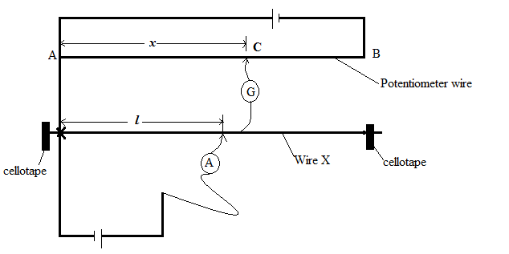
- Starting with length l = 10m, determine point C on the potentiometer wire AB, where the galvanometer shows no deflection
- Measure and record the balance length x and the reading I of the ammeter A
- Repeat procedures (b) and (c) for = 0.3m
- Calculate the mean value β of the quantity from the expression β= $\frac{1}{x}$ .
- Find the resistance per metre, k of the wire from the expression.
k = $\frac{1.5}{β}$
Method II:
- Connect the circuit shown below:
- Starting with a length lof loop of the wire X of 0.15m, close switch k₁
- Move the sliding contact along the sliding wire of the metre bridge until a point is found where the galvanometer G shows no deflection.

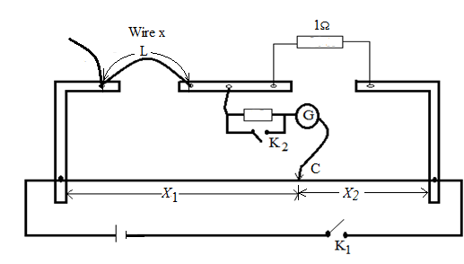

- Close switch K₂ and locate the balance point C accurately.
- Record the balance lengths X₁ and X_{2 .}
- Open switches K₁ and K₂.
- Repeat procedures (b) to (f) for values of l = 0.20, 0.20, 0.25, 0.30, 0.35, 0.40 and 0.45m.
- Tabulate your results including values of $\frac{x_{1}}{x_{2}}and\frac{l}{2}$.
- Plot a graph of$\frac{l}{2}$against $\frac{x_{1}}{x_{2}}$.
- Find the slope, S of the graph.
- Calculate the resistance per metre, r of wire x from the expression r = $\frac{1}{s}$
- Comment on the accuracy of the values of k and r.

EXPERIMENT 61
In the experiment you will determine the resistance per meter length of the wire provided
PART 1
- Connect the dry cell, a rheostat Q a switch K, ammeter A and a resistor of 5Ω in series as shown in the figure below.
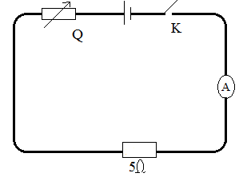
- Close switch K.
- Adjust the rheostat until the ammeter registers a current, I = 0.08A
- Disconnect the circuit, but keep the setting of the rheostat unaltered.
- Connect the circuit shown in the figure below
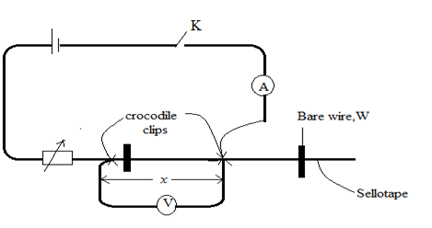
- Close switch K
- Without altering the setting of the rheostat, adjust the position of the crocodile clips until the reading of ammeter ,I = 0.08A
- Read and record x_{o} of the bare wire W between the two crocodile clips.
- Open switch K.
- Calculate the resistance per meter length, r_{o}from :r_{o}= $\frac{5}{x_{0}}$.
- Close switch K
- Adjust the length of the bare wire, between the crocodile clips such that x = 0.200m.
- Adjust the rheostat until the ammeter registers a current, I = 0.08A
- Read and record the voltmeter reading, V.
- Repeat the procedures l) to n) for values of x = 0.300, 0.400, 0.500, 0.600 and 0.700m.
- Disconnect the circuit
- Tabulate your results including values of $\frac{1}{V} and\frac{1}{x}$.
- Plot a graph of $\frac{1}{V} against\frac{1}{x}$.
- Determine the slope, R₁ of the graph.
PART 11
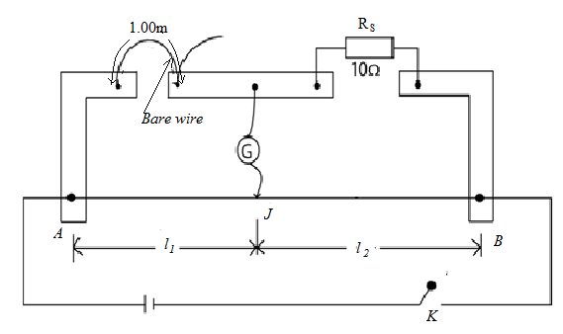
- Connect the circuit shown above with 1.00m length of the bare wire Q connected in the left-hand gap of the meter bridge
- Connect the standard resistor, R_{s} = 10Ω in the right hand gap of the meter bridge.
- Close switch K.
- Move the sliding contact, J, along the meter bridge wire AB to locate a point which the galvanometer shows no deflection.
- Read and record the balance length l₁and l₂.
- Open switch K
- Calculate the resistance per meter length, r₂ of the bare wire, W, from
r₂ =$\frac{R_{s }l_{1}}{l_{2}}$
- Repeat procedures b) to f) with R_{s} = 5Ω
- Calculate the resistance per meter length, r₃ of the bare wire, W, from
R₃ =$\frac{R_{s }l_{1}}{l_{2}}$
- Calculate the average of r₀, r₁, r₂ and r₃.

EXPERIMENT 62
In the experiment you will investigate the cooling of a hot object by natural convention
- Place the calorimeter provided on the block provided
- Boil water in a beaker.
- Pour hot boiled water into the calorimeter until the beaker is about two thirds full.
- Stir for 10seconds, read and record the temperature of water
- Read and record the temperature of water at an interval of 60seconds until the temperature is slightly below 40⁰C.
- Plot a graph of temperature against time.
- At any 4 spaced points on the curve, draw tangents and determine the slope S at these points.
- Calculate the excess temperature (θ-θ₀) where θ₀ is the temperature of the surrounding corresponding to each point.
- Plot a graph of S against (θ-θ₀).
- Comment on your graph.

EXPERIMENT 63
In the experiment you will determine specific heat capacity of brass by two methods of cooling.
- Measure and record the mass Mc kg of the calorimeter
- Heat water in a beaker to 95⁰C.
- Measure out 100ml of hot water and transfer it into a calorimeter and stir for 5seconda.
- Read and record the temperature, θ of water in the calorimeter and simultaneous start the stop clock.
- Read and record the temperature of water with the calorimeter after every 60seconds for 15times and tabulate your results.
- Plot a graph θ against time.
- From the graph find the time interval t₁ that elapses for temperature to fall from 70⁰C to 60⁰C.
- Pour out the contents from the calorimeter.
- Place a 100g of brass into the calorimeter and repeat procedure b) to f).
- Plot a graph of temperature of water, brass and the calorimeter against time.
- From the graph find the time interval t₂ that elapses for temperature to fall from 70⁰C to 60⁰C.
- Find the specific heat capacity of brass from:
S =$\frac{\left({380M}_{C}+ 418\right)(t_{2}- t_{1})10}{t_{1}}$

EXPERIMENT 64
In the experiment you will determine specific heat capacity, c_{s} of aluminum by method of mixtures.
- Weigh the mass Mc copper calorimeter and stirrer using a lever brash.
- Half fill the calorimeter with water, measure and the mass Mw of the calorimeter with water and the stirrer.
- Place the calorimeter in the insulating jacket.
- Stir the water thoroughly and measure the temperature θ₁ of water with the calorimeter.
- Weigh the small mass, Msof block and record.
- Place the aluminum block in the boiling water and wait for about 10minutes for the block to assume the temperature of the boiling water.
- Measure and record the temperature, θ_{b} of the boiling water.
- Quickly transfer the aluminum block from the boiling water into the calorimeter.
- Stirring continuously, monitor the temperature θ_{f}of the mixture.
- Measure an record the temperature, θ_{f} attained the water and calorimeter.
- Tabulate your results in a suitable table.
- Calculate the specific heat capacity, c_{s} of aluminum block from
M_{s}c_{s}(θ_{b}- θ_{f} ) = M_{c} c_{c} + M_{w}c_{w}(θ_{f}- θ_{b})
Where c_{w =} 4.2 X 10³ Jkg⁻¹K⁻¹and c_{c}= 3.9 X 10² Jkg⁻¹K⁻¹

